Canberra Health Services
Clinical Procedure
Infection Prevention and Control - Healthcare Associated Infections

Contents

Section 1. Contents 1
Section 2. Purpose 5
Section 3. Scope 5
Section 4. Governance and systems for infection prevention & control and surveillance 5
4.1 Procedure 5
Section 5. Infection prevention and control strategies 7
5.1 Standard precautions 7
5.2 Hand Hygiene 7
5.2.1 Procedure 7
5.2.2 Promoting patient, visitor and volunteer Hand Hygiene 8
5.2.3 Hand Hygiene auditing 8
5.2.4 Requirements for clinical glove use 9
5.2.5 Appropriate attire for healthcare workers in the healthcare setting 9
5.2.6 Skin care requirements 10
5.2.7 Placement of hand hygiene products 11
5.2.8 Contact tracing 13
5.3 Personal Protective Equipment 14
5.3.1 Gowns 14
5.3.2 Gloves 15
5.3.3 Face and eye protection 17
5.3.4 Masks 18
5.4 Aseptic technique 22
5.5 Single patient use equipment/items 22
5.6 Transmission based precautions 22
5.6.1 Contact precautions 23
5.6.2 Droplet precautions 24
5.6.3 Airborne precautions 25
5.6.4 Impact of transmission-based precautions on patients and their family 26
5.7 Notifiable diseases 26
5.7.1 Procedure 26
5.8 Exclusion periods for healthcare workers exposed to or with an infectious condition 31
5.8.1 Procedure 31
5.9 Code of dress or attire in restricted/semi restricted procedure areas 33
5.9.1 Scrub attire 33
5.9.2 Scrub attire outside of restricted/semi restricted area 33
5.9.3 Headwear 34
5.9.4 Footwear 34
5.9.5 Jewellery 34
5.9.6 Fingernails 34
5.9.7 Surgical masks 35
5.9.8 Protective eyewear 35
5.9.9 Radiation protection 35
5.10 Occupational Medicine Unit procedures 36
Section 6. Managing patients with infections or colonisation of pathogens 36
6.1 Multi-resistant Organism screening and clearance 36
6.1.1 MRO screening 36
6.1.2 MRO clearance 36
6.1.3 Healthcare facility transfer screening 37
6.2 Management of a patient suspected or identified with an MRO in Acute Care Settings 37
6.2.1 Equipment 37
6.2.2 Procedure 37
6.2.3 Core strategies 37
6.2.4 Additional requirements for the care of children with a MRO 39
6.2.5 Notification requirement 39
6.3 Management of a patient suspected or identified with an MRO in a multi bed room 40
6.3.1 Equipment 40
6.3.2 Procedure 40
6.3.3 Management of other patients in the room 40
6.3.4 Management of the vacated bed space 41
6.4 Management of patients suspected or identified with a MRO in the Subacute Unit 41
6.4.1 Procedure 41
6.4.2 Placement of patients 41
6.4.3 Movement of patients within the unit 41
6.4.4 Visitors 42
6.4.5 Screening of patients in a Subacute Unit 42
6.4.6 Transfer of MRO patients from Subacute to an Acute Care Unit 42
6.5 Vancomycin Resistant Enterococcus - probiotic treatment 42
6.5.1 Procedure 42
6.5.2 Duration of yoghurt therapy 43
6.5.3 If patient remains positive for VRE: 43
6.5.4 For a patient to be confirmed VRE negative post treatment 43
6.6 Management of patients suspected or identified with an infectious illness in outpatient settings 43
6.6.1 Procedure 43
6.6.2 Droplet precautions 44
6.6.3 Airborne precautions 44
6.6.4 Notification requirement 45
6.7 Negative Pressure or Positive Pressure rooms 45
6.7.1 Negative Pressure or Positive Pressure Room/Ward features 46
6.7.2 Infection prevention and control 47
6.7.3 Property Management and Maintenance Unit, Infrastructure Support 47
6.7.4 Clinical Staff 47
6.7.5 Ward/Unit performance monitoring 47
6.8 Management of Multi–resistant Organisms in Operating Theatres 51
6.8.1 Preparation of Operating Theatre and surrounding area 51
6.8.2 Management of patients with Tuberculous (TB): 51
6.8.3 Transport of the MRO patient within Perioperative Unit 52
6.8.4 Management during and on completion of surgical procedure for the patient with MRO 52
6.8.5 Scrub nurse responsibilities 53
6.8.6 Caring for patients in Post Anaesthetic Care Unit that require infection control precautions 54
6.9 Outbreak management 54
6.9.1 Outbreak management team members 54
6.9.2 Preliminary phase 55
6.9.3 Control measures 55
6.9.4 Nursing care 55
6.9.5 Cohorting 56
6.9.6 Admission and discharges 56
6.9.7 Patient movements within the Health Care Facility 56
6.9.8 Documentation 56
6.9.9 Staff 56
6.9.10 Visitors 57
6.9.11 Environmental services 57
Section 7. Animals, toys and plants in the Health Care Setting (Acute and Community) 57
7.1 Animals or pets in Health Care Setting (Acute and Community) 57
7.1.1 Procedures 57
7.1.2 Patients and staff 58
7.1.3 Animals 58
7.1.4 Mandatory requirements for visiting animals 59
7.1.5 Environmental considerations 59
7.2 Toys in the workplace 60
7.2.1 Purchasing/obtaining toys 60
7.2.2 Cleaning of toys 61
7.2.3 Storage of toys 61
7.3 Flowers and pot plants 62
7.4 Mobile phones and electronic equipment 62
Section 8. Ward laundering and patient equipment cleaning 62
8.1 Laundering Practices 63
8.1.1 Machines and dryers 63
8.1.2 Powder 63
8.1.3 Laundry areas 63
Section 9. Antimicrobial Stewardship 63
Section 10. Cleaning Disinfection and Sterilisation Standard 63
10.1 Waste management – identification, streaming and safe handling 63
10.1.1 Basic principals - Personal Protective Equipment and Infection Control 64
10.1.2 Clinical and related wastes 64
10.2 Reprocessing reusable medical devices used in patient care 65
10.2.1 Procedure 65
10.2.2 Reprocessing of critical items 66
10.2.3 Reprocessing of semi-critical Items 66
10.2.4 Reprocessing of non-critical items: 66
10.2.5 Reprocessing of instruments where a risk of CJD transmission 66
10.2.6 Reprocessing of items designated as single use items MUST NOT occur 66
10.2.7 Spaulding Classification for reprocessing 67
10.2.8 Purchasing 68
Section 11. Facilities management 68
11.1 Contractors 68
11.2 Air conditioning units 68
11.3 Water management for Legionella 68
11.4 Sampling program protocol 69
11.5 Investigation and Treatment of Hospital Acquired Pneumonia in the Setting of Detection of Legionella pneumophilia from Ward Water Outlets 70
11.6 Refrigeration units 72
11.7 Sterilisers, washer/disinfectors, ultrasonic cleaners, aeration cabinets & associated equipment 72
11.8 Negative Pressure isolation room 73
Section 12. Designing or refurbishing a new or existing building 73
12.1 Purchasing new product, equipment or other commodities 73
12.2 Purchasing contracted services 74
12.3 Pest control 74
12.4 Infection control during construction and renovation 74
12.4.1 Procedure 74
12.4.2 Construction and renovation assessment 74
12.4.3 Infection control activities 79
12.4.4 Engineering/major project activities 79
Section 13. Communication with patients and carers 79
13.1 Patient information pamphlets 79
Section 14. Implementation 79
Section 15. Related Policies, Procedures, Guidelines and Legislation 80
Section 16. References 81
Section 17. Definition of terms 83
Section 18. Search terms 85
Section 19. Attachments 85
Attachment A - Clearance requirements for microorganisms 87
Attachment B - Waste Streaming 93

Purpose

The purpose of the Healthcare Associated Infection (HAI) procedure is to outline systems and processes to ensure effective organisation wide evidence based strategies, to prevent staff and patients from acquiring preventable healthcare associated infections and effectively manage infections when they occur.

This document is a combination of all HAI related procedures and has been aligned against the National Safety and Quality Health Service (NSQHS) Standards actions list for HAI.

Scope

This procedure applies to all Canberra Health Services (CHS) staff, students and trainees undertaking clinical placement and all contracted agents working on CHS premises, and where appropriate specific areas may be identified.

Governance and systems for infection prevention & control and surveillance

Procedure
The CHS Infection Prevention and Control Unit (IPCU) will:
- Provide promotion, education, support and assistance to staff to promote safe, high quality patient care and customer service.
- Assist divisions and branches within CHS to develop and maintain current best practice procedures specific to their field of expertise.

Assist staff members to:
- Identify major infection risks in accordance with legislative requirements.
- Ensure any responsibilities relating to notification of diseases are met.
- Ensure staff are educated in and understand their infection prevention and control responsibilities through initial orientation training and other in-service education as appropriate and/or required, e.g. hand hygiene (HH), use of personal protective equipment (PPE), influenza and outbreak management, standard and additional precautions, staff health and vaccination and adherence to aseptic technique.
- Liaise with other internal and external divisions to ensure external/contracted service providers, carers and volunteers, students and visitors comply with the organisation's infection prevention and control requirements, e.g. compliance with 5 Moments for Hand Hygiene across identified CHS service delivery areas, use of personal protective equipment and standard/additional precautions.
- Conduct authorised surveillance and data collection for the purpose of identifying trends in infection rates by:
- Investigating and instigating corrective processes to reduce infection rates.
- Investigating and implementing changes to equipment or procedures to reduce infection rates.
- Conducting or coordinating education programs associated with infection prevention and control practice change.
- Conduct or supervise authorized audits of CHS workplaces, such as clinical spaces, staff rooms, and/or storage areas.
- Evaluate changes to ensure they are effective in addressing identified specific infection prevention and control issues.
- Liaise with the Occupational Medicine Unit (OMU), Injury Prevention and Management Unit, programme and divisional Directors, Team Leaders, Clinical Nurse Consultants and Clinical Development Nurses to raise awareness of, and reduce the incidents of, occupational exposure to infectious agents.
- Create policies/procedure/guidelines based on the best available evidence as required
- Educate relevant parties regarding policies and assist with implementation, as required
- Audit breaches to infection prevention and control best practice (e.g. workplace audits/Riskman).

CHS staff will:
- Ensure they are immunised according to the Occupational Assessment, Screening and Vaccination procedure and that their immunisation record is provided to OMU.
- Undertake orientation training.
- Complete annual infection prevention and control update education, including HH, by utilising:
- Face to face educational opportunities
- On-line e-learning packages through Staff Development Unit (SDU) and 'Capabiliti'.
- Ensure that they understand and comply with the procedure relating to:
- Work practices
- Patient safety.
- Report, in a timely manner, any breaches of infection prevention and control best practice or exposure to an infectious agent reported via Riskman.
- Incorporate infection prevention and control into:
- Workplace specific orientation
- All team meeting agendas
- Staff credentialing and clinical practice assessment and
- Patient care planning and service provision.
- Ensure PPE procedures and standard/additional precautions are adhered to.

Student and trainees undertaking clinical placement will:
- Ensure they are immunised according to the Occupational Assessment, Screening and Vaccination Procedure and that a copy of their immunisation record is provided to OMU.
- Ensure that they are familiar with procedures relating to:
- Work practices
- Patient safety
- Report to infection prevention and control, in a timely manner, any breaches of best practice or exposure to an infectious agent.
- Ensure PPE procedures and standard precautions are adhered to.

Back to Table of Contents

Infection prevention and control strategies

Standard precautions
Standard precautions are work practices that are required to maintain the basic level of infection prevention and control. Standard precautions are recommended for the treatment and care of all patients, and when in contact with all body fluids, secretions and excretions (excluding sweat), regardless of whether they contain visible blood (and include dried bodily substances such as dried blood or saliva), non-intact skin and mucous membranes.

Standard precautions must be used for the treatment and care of all patients, regardless of their known or perceived infectious status.

- Perform HH before and after every patient contact.
- Use PPE when there is a risk of body fluid exposure.
- Use and dispose of sharps safely.
- Perform routine environmental cleaning.
- Clean and reprocess share patient equipment.
- Follow respiratory hygiene and cough etiquette.
- Use aseptic technique.
- Handle and dispose of waste and used linen safely.

Hand Hygiene

Procedure
HH includes one of the following:
- Hand washing with liquid soap and water
- Decontamination utilising Alcohol Based Hand Rub (ABHR)
- Using alcohol impregnated wipes by community based staff.

When to perform HH:
The designated 5 Moments for HH must be used by all staff when attending to patient care and can be performed with either soap and water, ABHR or alcohol impregnated wipes.
- Moment 1: Before touching a patient.
- Moment 2: Before a procedure.
- Moment 3: After a procedure or body fluid exposure risk.
- Moment 4: After touching a patient.
- Moment 5: After touching a patient’s surrounding.

Before:
- Handling contact lens.
- Eating and handling food.

Between:
- Handling different types of food – raw and cooked, hot and cold, meat and vegetables.

After:
- Any activity that results in hands becoming dirty or contaminated with blood or body substances (use soap and water).
- Removing gloves or PPE.
- Handling any type of waste material.
- Handling pets or pets waste products.
- After environmental/instrumental/equipment cleaning.
- Smoking; and personal care/hygiene.

Reminders:
- All staff have a responsibility to remind other staff members of the need for HH if they observe a member of staff who fails, or is about to fail, to perform HH in line with this procedure. Such reminders must be delivered in a courteous and supportive manner to support all staff to achieve a high standard of patient care.

Promoting patient, visitor and volunteer Hand Hygiene
- Staff should encourage patients to perform HH after going to the toilet, using a bedpan, urinal, before eating and after sneezing or coughing into hands.
- HH products should be offered to bed ridden patients to promote HH.
- Staff should educate patients on correct HH technique.
- Visitors and volunteers should be encouraged to comply with HH products before entering patient room/ward.

Hand Hygiene auditing
- HH auditing is conducted by trained auditors three times per year according to Hand Hygiene Australia’s specifications.
- The audit measures when HH is performed according to the 5 Moments for HH.
- The number of observations to be undertaken is determined by the size of the healthcare facility.
- Auditing should reflect a cross section of the hospital’s staff and shifts, and not just repeated or prolonged observations of a small number of staff.
- Auditing should reflect a cross section of patient care episodes in a range of settings and not prolonged observation of single episodes of patient care.
- HH audit information must be available to healthcare professionals on their ward/unit/service.

Requirements for clinical glove use
- Wearing gloves does not eliminate the need for HH.
- Wear gloves when contact with body fluids is anticipated as required using Standard Precautions.
- Change gloves during patient care if moving from a contaminated body site to a clean body site.
- Remove gloves after caring for a patient. Do not wear the same pair of gloves for the care of more than one patient.
- Change and discard gloves if they become torn, punctured or compromised in any way.
- Gloves must not be sanitized, washed or reused.

Appropriate attire for healthcare workers in the healthcare setting
All staff working in healthcare should present a professional image and support safety through an approved standard of dress. All staff will be bare below the elbow to allow for effective HH.

Clothing/uniform:
- Clothing worn by all staff must be clean and fit for purpose.
- Perfume and aftershaves must be kept to a minimum for patient comfort and to prevent triggering of allergies in susceptible patients and staff.
- Uniforms must be kept clean, in good condition and wrinkle free.
- Washable sweaters, vests, jackets may be worn to and from work or during breaks to provide additional warmth. It is important that personal apparel is laundered regularly.

Hair:
- Hair must be off the shoulder and/or tied back and up and clear of the face. Short, off the collar, or secured in a way that avoids hair falling over the shoulders.
- Dreadlocks or braids, if worn, must be clean, well maintained, and, if below the collar, must be secured.
- Hair accessories must be functional and kept to a minimum.
- In all circumstances hair, beard and moustaches must be clean, tidy and trimmed.
- Beards should be neatly maintained to comply with policies and procedures (e.g. wearing of masks). Facial hair must not interfere with the effectiveness of personal protective equipment.
- Headscarves or veils worn for religious reasons must not interfere with work practices. To reduce risk of cross infection, employees must ensure the garment is neatly tied back. The scarf / veil must be clean and changed on a daily basis.

Jewellery, lanyards, neckties and personal equipment pouches can be a source of infection:
- Jewellery should not inhibit proper HH.
- Rings should be limited to one plain flat band.
- No wrist watches, bracelets, fitbits or Applewatches are to be worn in a clinical area.
- Earrings that are large and dangling must not be worn. Only small studs or simple studs may be worn.
- Jewellery should be removed if it presents a potential hazard to patients, other staff and/or when using equipment.
- Lanyards should not be used by clinical staff when performing procedures when contamination from lanyards is possible.
- Avoid wearing neckties when carrying out clinical activities.
- Personal equipment pouches should be avoided due to the risk of being contaminated with pathogenic organisms.
- Personal private mobile phones must not be carried whilst on duty.

Fingernails:
- Fingernails should be kept short, clean and healthy at all times.
- Nail polish and nail enhancements should not be worn by healthcare workers providing patient care. Enhancements include anything applied to natural nails –i.e. artificial nails, tips, wraps, acrylics, shellac, gels and any additional item applied to the nail surface. Chipped nail polish supports the growth of micro-organisms on the fingernails.
- Gel and Shellac nails are different sorts of polish and fake nails.
- Gel is a stronger more flexible fake nail.
- Shellac is a stronger and thicker nail polish that doesn’t break or crack as easily.
- Gel and Shellac have the potential to become reservoirs for microorganisms posing a transmission risk to patients, staff and the environment and should not be worn by health care workers providing patient care.

Dermal Piercings:
- Dermal piercings below the elbow are not acceptable when working in clinical areas as they inhibit the ability of the clinician to practice proper and effective hand hygiene and may be a source of micro organisms.
- Clinical staff with dermal piercings below the elbow, who were employed by the organisation prior to the implementation of this policy, must cover each piercing with an appropriate clean waterproof dressing. Gloves are only to be worn when standard precautions need to be applied.

Footwear;
- Consider the potential hazards of their work environment when choosing suitable footwear. This includes the risk of spills of contaminated fluids onto shoes and the risk of heavy objects falling or being rolled over shoes. Shoes are to be non- permeable and enclosed with a flat or low heel. Gum boot are not acceptable.
- Footwear with slip resistant soles, closed toe and closed heel with a solid upper covering (no holes on the top or side of the shoe) must be worn.

Skin care requirements
- Use only supplied CHS HH products.
- Ensure hands are wet before application of soap for hand washing.
- Use warm water for hand washing whenever possible – extremes of temperature can damage skin.
- Moisturise hands at least four times during the shift to prevent dryness and skin abrasions. However, this is not applicable to Sterilising staff when working in the packaging area as stated in AS4187.
- Cover cuts and abrasions with an occlusive waterproof dressing to prevent invasion of micro-organisms and replace dressings that become dislodged or damaged.
- For food service staff, cleaning staff and sterilising staff - wear appropriate protective gloves to minimise risk of damage from extremes of temperature and chemicals.
- Report and seek prompt medical attention for any skin problems related to the use of HH products.
- Seek professional advice for skin infections and dermatological conditions.

Placement of hand hygiene products
- Placement of products should be easily accessible for staff to be able to perform HH according to the 5 Moments for HH.
- ABHR must be available at the point of care and all adult beds must have ABHR attached preferably on the left hand side of the foot of the bed rest.
- ABHR is to be available at the entry to all healthcare facilities and at the entry to the ward and clinical areas.
- In paediatric/adolescent settings placement of product is at the point of care, either on the end of the bed or as close to the end of the bed as possible, except in situations of intellectual impairment or alcohol abuse where children could unintentionally or intentionally harm themselves. In this situation an empty bottle of product should be placed in the bracket at the end of the bed, to avoid the bracket itself becoming a source of potential harm.
- Procedure trolleys should have ABHR attached to them to allow easy access for staff to be able to perform HH.
- Education and support regarding the importance of ABHR’s must be given to the patient and their family members.
- All clinical areas must have adequate ABHR to allow easy access during clinical procedures.
- Hand washing basins should be kept clear of excess items to allow easy access for hand washing.
- The staff of wards and departments should ensure adequate supplies of the products are available for use at all times.

Staff should not:
- Remove the ABHR brackets from the end of the bed, in adult patients see above.
- Re-use dispensing plunger.
- Refill containers of HH products.
- Top up part filled containers.
- Use out-of-date products.
- Bring commercially available products in from home as these are unsuitable for a healthcare environment and not compatible with hospital hand hygiene products and they may not be compatible with latex.
- Use products provided by patients.

Type of hand hygiene | Purpose | Method | Indications/ Notes
General hand hygiene  (See chart 1) | Remove transient microorganisms following general patient or environmental contact | Neutral soap and water for at least 30 seconds or ABHR for at least 10-15 seconds  Community staff can use soap and water wipes | - Neutral soap and water is recommended for general/ social hand hygiene  - Alcohol based hand rub (ABHR) may be used as an alternate to general hand- washing. Apply hand rub to hands rub vigorously over all surfaces of hands until dry 10 - 15 seconds  - If using neutral soap wet both hands with water, up to the elbows, before applying soap solution  - Refillable containers and reusable plungers are NOT recommended in any healthcare settings  - Contamination of HH products may occur if refillable containers are used
Procedural hand hygiene  Antiseptic/ antimicrobial handwashing agents, eg. Chlorhexidine gluconate 2%, Triclosan 1% or  ABHR | Remove or destroy transient microorganisms prior to undertaking procedures requiring application of sterile gloves or prior to exposure to high risk patients | Antimicrobial agent and water for at least 60 seconds or ABHR for 10-15 seconds | - Before performing invasive procedures.  - Before contact with immuno-compromised patients  - Between contacts with different patients in high-risk units, e.g. intensive care, neonatal care, renal dialysis  - With certain types of Transmission-based Precautions (e.g. contact precautions)  - Soap residue may inactivate some antimicrobial agents.  - Therefore, rinsing is an important component of the hand hygiene technique  - ABHR may be used as an alternative to hand washing for general and pre procedural HH or in situations where running water is not available  - ABHR kill or inhibit the growth of microorganisms, these products do not remove soil/dirt and therefore are unsuitable if hands are visibly soiled
Surgical handscrub | Reduce, remove or destroy transient microorganisms and reduce resident flora prior to surgical procedures | Antimicrobial agent  First wash for the day - 5 minutes duration including the cleaning of fingernails  Subsequent washes between cases - 3 minutes duration, omitting fingernails | - Antimicrobial agents, e.g. Chlorhexidine gluconate 4%, Povidine-Iodine 7.5%  - Surgical scrub prior to surgical intervention including areas where angiography is performed
Source: adapted from Larson, APIC Guidelines and ACORN Standards for perioperative nursing 2016

Contact tracing
The following flow chart shows the contact tracing procedure for cases with specific notifiable infectious diseases, e.g. meningococcal, mumps, measles, whooping cough and chickenpox.

Any area identifying patient with a notifiable infectious disease, e.g. emergency department, ward, clinic or public health, should contact the team leader of OMU (44588), the IPCU (43695) and the Communicable Disease Control (CDC) section of the Health Protection Service (HPS) (6205 2155).

After hours the after hours Clinical Nurse Consultant (CNC), doctor or nurse caring for the patient should contact the CDC section of the HPS via the hospital switchboard. It is important to note that reporting to CDC is a legislative responsibility for doctors and nurses.

Figure 1 – Contact Tracing
Notifiable disease identified
Identifying area CNC/Team Leader will:
•
Contact OMU or IPCU regarding exposure to infectious illness/condition
•
Ensure patient is in correct additional precautions
•
Compile a list of all potential contacts of the index case
-
the list to
include clinical and non clinical staff
No
In
hours?
Yes
Identifying area CNC/Team Leader will:
•
Contact the after hours CNC
•
Ensure patient is in correct additional precautions
•
Compile a list of all potential contacts of the index case
-
the
list to include clinical and non clinical staff
The after hours CNC will
:
•
Ensure patient is placed in correct additional precautions
•
Will request a list of names for all contacts
–
staff and
visitors
•
Determine using the guideline if the follow up can wait
until the following day or if it is required to be undertaken
immediately
•
Will determine if IPCU need to be contacted after hours to
commence the contact tracing or if the work is able to be
handed over to IPCU for the next day
Conclusion of the contact tracing
-
IPCU to collect all information into one
folder and file into outbreak folder and report as necessary to CDC
and CHS management
IPCU will:
•
Check the patient is in the correct additional
precautions to reduce further exposure
•
Review all patients/visitors who require follow
up and their immune status as per disease specific
guidelines
•
Organize pathology testing as required for
inpatients and family
•
Organize prophylaxis if required.
•
Contact CDC (NSW or ACT depending on
postcode) if required
•
Review patient/visitor/staff immunity
OMU will:
•
Obtain a list of all staff that were in contact with the patient/visitor in
question (list to include all shifts, clinical and non clinical staff)
•
Will review staff as to their immunity
-
if staff are unaware of their immune
status pathology may be required. OMU to contact pathology to ensure
that bloods are tested in a timely manner
•
Inform Infectious Diseases (ID) Physician
•
To report back to team leader/CNC immune status and if consideration is
to be given to having staff member either go to non clinical work or take
leave
•
To organise prophylaxis for staff if required
•
Feed back to ID
References
Department of Health and Ageing, (2013) The Australian Immunisation Handbook 10
th
edition, www.immunise.health.gov.au
Department of Health and Aging, (2007) Guideline for the early clinical and public
health management of meningococcal disease in Australia, www.health.gov.au
Australian Society for Infectious Diseases, (2014) Management of
Perinatal
Infections

Personal Protective Equipment
PPE refers to a variety of barriers, used alone or in combination to protect mucous membranes, airways, skin and clothing from contact with infectious agents.

PPE used as part of standard precautions includes aprons, gowns, gloves, surgical masks, protective eyewear and face shields.

The selection of PPE is based on the type of patient interaction, known or possible infectious agents, and/or the likely mode(s) of transmission.

Gowns
Protective clothing (gown or apron) should be worn by all healthcare workers when:
- Close contact with the patient, materials or equipment may lead to contamination of skin, uniforms or other clothing with infectious agents.
- There is a risk of contact with blood, body substances, and/or secretions (except sweat).

Types of gown Vs type of activity
Note that clinical and laboratory coats or jackets worn over personal clothing for comfort and/or purposes of identity are not considered to be PPE and should be laundered frequently.
- A clean non-sterile gown or apron is generally adequate to protect skin and prevent soiling of clothing during procedures and/or patient-care activities that are likely to generate splashing or sprays of blood or body substances.
- A fluid-resistant apron or gown should be worn when there is a risk that clothing may become contaminated with blood, body substances, secretions or excretions.
- Long sleeved, disposable, non sterile gowns should be used when contact precautions are required.
- Sterile gowns are required for procedures requiring an aseptic technique and field.

Wearing of gowns
- Gowns and aprons must be changed between patients.
- Gowns should be put on immediately prior to patient care activity.
- Gowns should be worn correctly, i.e. covering shoulders, opening at the back and tied at the back.

Removal of gowns
- Important to remember to remove gloves then perform hand hygiene prior to removing gown.
- Remove gowns before leaving the patient-care area, e.g. in the room or anteroom, to prevent possible contamination of the environment outside the patient’s room.
- To remove gown, the outer ‘contaminated’, side of the gown is turned inward and rolled into a bundle, and then discarded into a designated container for waste or linen.

Gloves
- Note that gloves are not required for routine patient care, e.g. taking temperatures, blood pressures or for subcutaneous, intramuscular or intradermal injections, unless exposure to blood or body fluids is anticipated. Other examples when glove use is generally not required are: patient transport, meal delivery/pickup, flower persons moving from ward to ward, at the desk, on the phone, mobilising patients in the corridor and cleaners as per their protocol.
- Gloves can protect both patients and healthcare workers from exposure to infectious agents that may be carried on hands, see figure 2 below.
- Gloves are used to prevent contamination of healthcare workers hands when:
- Anticipating direct contact with blood or body substances, mucous membranes, non-intact skin and other potentially infectious material.
- Handling or touching visibly or potentially contaminated patient-care equipment and environmental surfaces.
- Caring for a patient in contact precautions or with a transmissible agent.
- When transporting patients who require contact precautions (e.g. due to multi-resistant organism - MRO) health care workers should:
- Perform HH prior to entering patient’s room and then don gown and gloves as the healthcare worker organises the patient for transfer.
- As the healthcare worker leaves the patient’s room the gloves are removed followed by HH, then the gown is removed and HH repeated.
- The patient is transported without gowns or gloves.
- On arrival at the destination with the patient, it should be communicated to the staff receiving this patient that they require contact precautions (e.g. due to MRO).

Non-sterile gloves
- Used for potential exposure to blood, body substances, secretions or excretions and contact with non-intact skin or mucous membranes.

Sterile gloves
- Used for contact with susceptible sites or clinical devices where sterile conditions should be maintained.

Reusable utility gloves
- Indicated for non-patient-care activities (sterilising technicians use disposable single use gloves).
- Intended for use when a more physically protective glove is required.
- Clean according to the manufacturer’s instructions and stored dry between uses and replace when they are showing signs of deterioration.

Wearing of gloves
- Gloves are single-use items and should be put on immediately before a procedure and removed as soon as the procedure is completed, as per AS/NZS 4011.1 and 4179.
- Gloves must be changed between patients and after every episode of individual patient care.
- HH should be performed before putting on gloves and after removal of gloves.
- Single use gloves should not be washed, but discarded.

When gloves are to be changed
- If they are damaged.
- Between episodes of care for different patients, to prevent transmission of infectious material.
- During the care of a single patient, to prevent cross-contamination of body sites, i.e. if moving from an unclean to a clean site.
- If the patient interaction involves touching portable computer keyboards or other mobile equipment that is transported from room to room.

Removing and disposing of gloves
- When removing gloves, care should be taken not to contaminate the hands.
- After gloves have been removed HH should be performed in case infectious agents have penetrated through unrecognised tears or have contaminated the hands during glove removal.
- Gloves must not be washed for subsequent re-use—infectious agents cannot be removed reliably from glove surfaces and continued glove integrity cannot be ensured.
- Gloves should be disposed into suitable waste receptacle, as soon as they are removed.

Figure 2 – Summary of Glove Protection
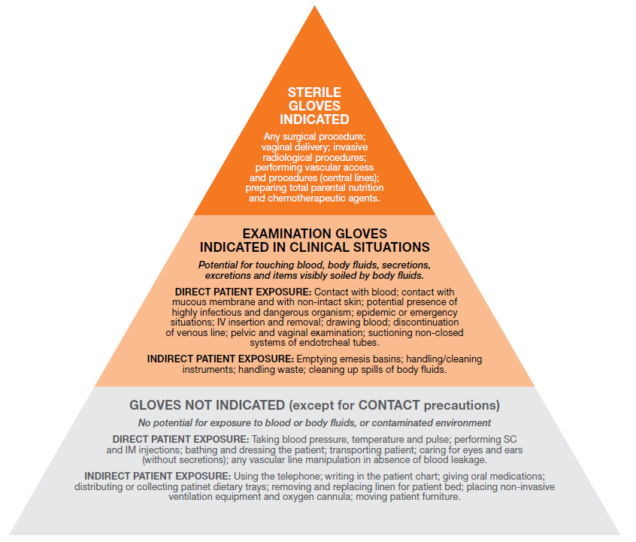
Source: WHO Guideline on Hand Hygiene in Health Care First Global Patient Safety Challenge
Clean Care is Safer Care (2009)

Face and eye protection
- Face and eye protection reduces the risk of exposure of healthcare workers to splashes or sprays of blood and bodily substances (secretions and excretions) and is an important part of standard precautions.
- Procedures that generate splashes or sprays of blood, body substances, secretions or excretions require either a face shield or a mask worn with protective eyewear.

Eye protection
- Goggles must fit snugly on the face, particularly from the corners of the eye across the brow, to provide reliable protection from splashes, sprays, and respiratory droplets from multiple angles.
- Goggles are available that fit over prescription glasses with minimal gaps.
- Personal eyeglasses and contact lenses are not considered adequate eye protection and the AS/NZS 1337 series should be consulted for appropriate eye protection.
- While effective as eye protection, goggles and safety glasses do not provide splash or spray protection to other parts of the face.
- Reusable eye protection should be cleaned with detergent solution or impregnated wipes and be completely dry before being stored.

Face shields
- Single-use or reusable face shields may be used in addition to surgical masks, as an alternative to protective eyewear.
- Face shields extending from chin to crown provide better face and eye protection from splashes and sprays than goggles.
- Face shields that wrap around the sides may reduce splashes around the edge of the shield.
- Reusable face shields should be cleaned with detergent solution or impregnated wipes and be completely dry before being stored.

Masks
In order for a surgical mask and P2/N95 mask to offer the desired maximum protection, it is essential that the wearer performs a safety check on the mask by properly fit checking the mask each time they wear one. Fit checking involves a quick check of the mask once it is applied to ensure that it is fitting the wearer properly and that a good seal has been achieved over the bridge of the nose and the mouth and there are no gaps between the mask and the wearer’s face (see figure 1 on the correct sequence for fit checking).

All mask users are encouraged to actively observe each other’s mask fitting and immediately advise the wearer of any fitting issues to maximise the user’s safety. All staff working in areas that require the donning and doffing of PPE must undergo training on how to appropriately perform a fit check at the point of use.

Figure 1: Fit checking of a P2/N95 mask
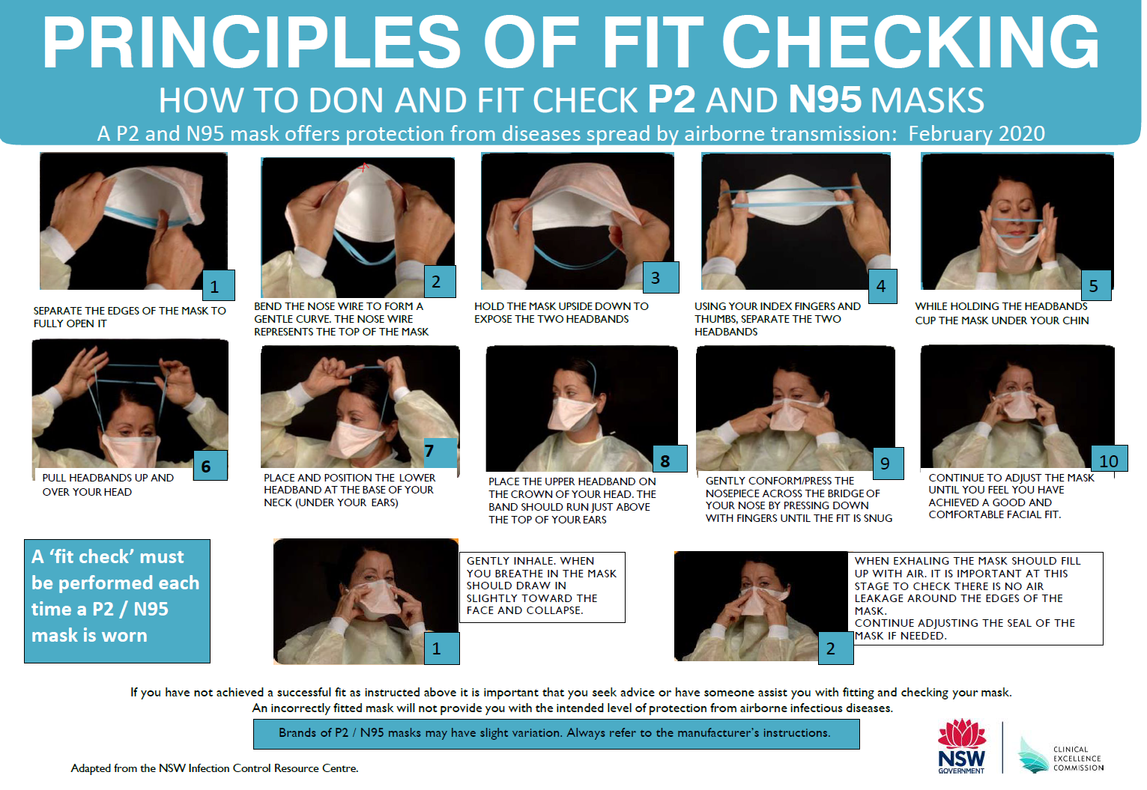

Fit testing is a method that is used to evaluate and identify the fit of a specific make, model and size of a mask on an individual. It also provides an opportunity to ensure mask users are properly trained in the correct use of the mask. It is important to note that the level of facial fit that the mask might provide is subject to influences from a variety of factors such as the mask design, facial sizes and any changes to the wearer’s facial characteristics such as beards, facial traumas or surgeries, facial piercings that lie along the sealing area of the mask, and significant weight changes. All these can alter the facial seal of the mask. Therefore, any staff member who is required to undertake fit testing may only wear approved facial hair styles as indicated in figure 2.

It is essential to keep in mind, that regardless of which type of fit test method is used to perform a fit test, a successful fit test only qualifies the user to wear the specific brand/make/model and size of P2/N95 mask that user wore during that test. The sizing of masks are not standardised across models or brands so users need to remember, that just because they pass a fit test wearing a particular size mask in one model or brand, it does not mean that they will have an equivalent fit in the same size in another model or brand.
Figure 2: Facial hairstyles
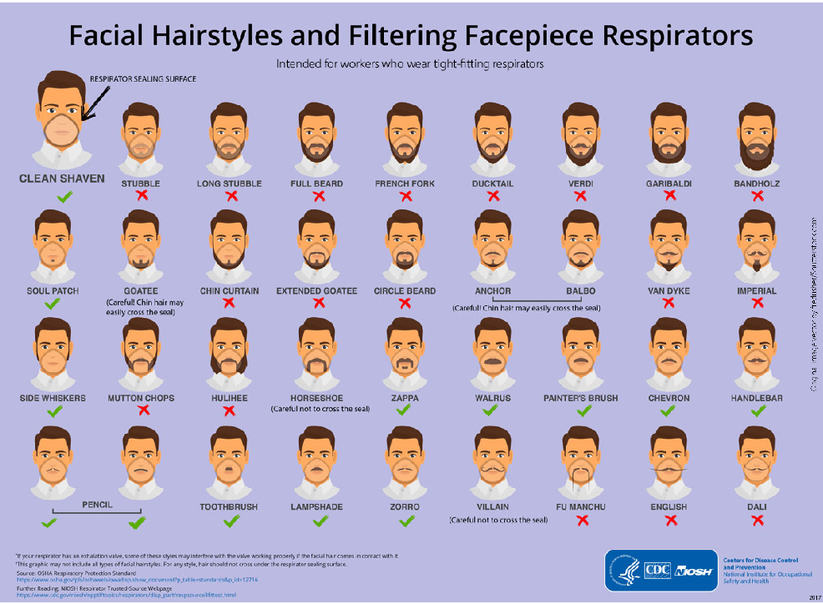

Surgical masks
- Surgical masks are used as part of standard and droplet precautions to keep splashes or sprays from reaching the mouth and nose of the person wearing them and should be used in accordance with AS 4381.
- Surgical masks when properly worn, block largeparticle droplets, splashes, sprays or splatter that may contain micro-organisms and keep them from reaching your mouth and nose. The size of particulates that are filtered by surgical masks is 3 microns.
- Surgical masks help reduce exposure of your oral secretions and respiratory secretions to others.
- They should be worn:
- For procedures or patient care activities that generate splashes or sprays of large droplets of blood, body substances, secretions and excretions.
- For procedures requiring a surgical aseptic technique (to protect patients from exposure to infectious agents carried in a healthcare worker’s mouth or nose).
- For routine care of patients on droplet precautions.
- For routine care of a patient in contact precaution when the microorganism is present in the sputum of the patient.
- By coughing patients to limit potential dissemination of infectious respiratory secretions from the patient to others.

Wearing of surgical masks
- Masks should be fit checked before each use.
- Masks should be changed when they become soiled or wet.
- Masks should never be reapplied after they have been removed.
- Masks should not be left dangling around the neck to be re applied at a later time.
- Touching the front of the mask while wearing it should be avoided as this area of the mask is contaminated.
- Patients in droplet precautions are to wear a mask when they are taken outside their room for transport to another clinical area.
- HH should be performed upon touching or discarding a used mask.
P2/N95(Respirators)
- Respirators are designed to help reduce the wearer’s respiratory exposure to airborne microorganisms and are appropriate for use when airborne precautions are encountered in healthcare facilities. As when aerosolising generating procedures are performed. These respirators can filter aerosol particulates that are between 0.3- 0.6 microns in size
- Care must be taken when placing respirators on patients with chronic obstructive airways disease (COAD) or is in respiratory distress as the respirator may exacerbate symptoms.
- P2/N95 should be worn by the HCW:
- For routine care of patients on airborne precautions.
- When performing high-risk procedures including aerosoling generating procedures.
- Worn by patient who is in airborne precautions when they are transported for procedures.
- Wearing a P2 / N95 / respirators
- In order to offer the maximum desired protection it is essential that the wearer is properly fit tested and trained in its safe use.
- HCWs must perform fit checks every time they apply a P2/N95.
- By fit checking the HCW s ensures the respirator is sealed over the bridge of the nose and mouth and that there are no gaps between the respirator and face.
- A facial seal cannot be achieved if the intended wearer has facial hair that lies along the sealing area of the respirator. See figure 2 guide on what facial hairstyles are suitable. Therefore, the wearer should ensure that their facial hair reflects the acceptable guide as outlined in figure 2.
- Respirators should not be touched while being worn.
- Respirators should be changed when they become moist.
- Respirators should never be reapplied after they have been removed.
- Respirators should not be left dangling around the neck to be re applied at a later time.
- HH should be performed upon touching or disposing of a used respirator.

Respirators should be removed outside the patient-care area and disposed of in an appropriate closed receptacle.

Figure 3 – summary of donning and removing PPE
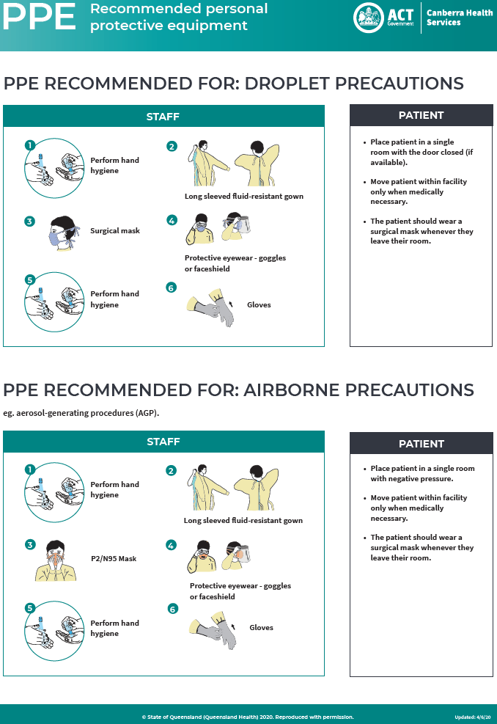
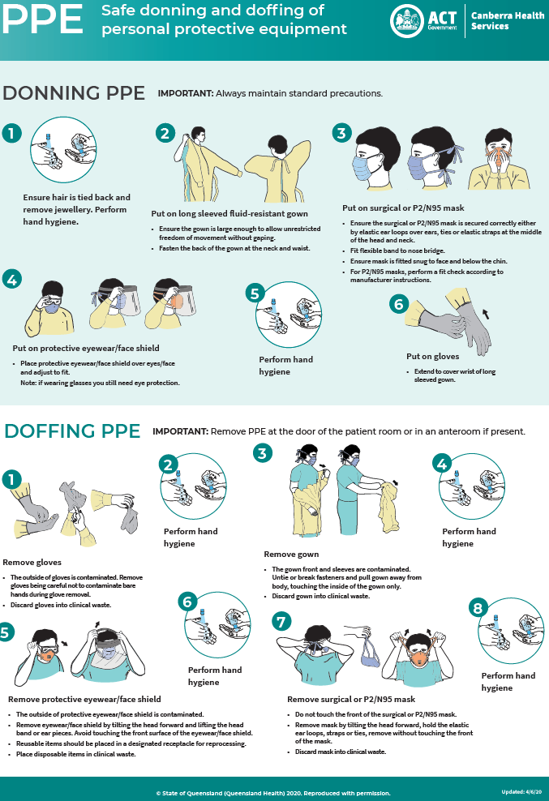

Aseptic technique
Asepsis is the purposeful prevention of the transfer of infectious agents. For details on aseptic techniques, please refer to Aseptic Non Touch Technique procedure, which can be found on the policy register (http://inhealth/PPR/default.aspx).

All clinical staff are to register via capabiliti (https://training.health.act.gov.au/ClientView/) and complete the e-learning module.

Single patient use equipment/items
Any designated single-use article or instrument that has penetrated the skin, mucous membrane or other tissue, e.g. intramuscular needles, must be discarded into the appropriate waste stream, immediately after use, or at the end of the procedure, whichever is more appropriate.

Single use items must not be re-used or reprocessed.

Single use item:
The item is to be used once only on an individual patient, during a single procedure, and then discarded at the point of use into an appropriate waste stream. It must be not reprocessed and used, on the same or another patient. These items have blue or green handles, as well as ‘single use’ impression marked on the instrument.

Single patient use:
The item must only be used on the same patient but may be used more than once (e.g. disposable tourniquet, disposable oxygen mask/respirator, disposable blood pressure cuff), providing it undergoes some form of cleaning between use.

Single use symbol

Transmission based precautions
Transmission based precautions are used for patients who are known or suspected to be infected or colonised with highly transmissible and/or infectious pathogens. They must be used in conjunction with Standard Precautions and frequently with each other and include:
- Contact Precautions:
- Direct with patient/person contact
- Indirect contact, i.e. contact with contaminated surface or equipment
- Droplet Precautions
- Airborne Precautions.

Contact precautions
Contact precautions are necessary in health care settings where infection transmission may occur due to direct or indirect contact with a transmissible agent.

Direct contact transmission
Direct contact transmission is the most common mode of transmission of health care associated infections, and occurs when microorganisms are transferred from one infected person to another person directly through skin contact.

This may occur during:
- Assisted personal care
- Medical, nursing or allied health care/procedures/activities
- Contact with friends, relatives and visitors
- Contact with other patients and their friends, relatives and visitors
- Contact with any equipment or clothing.

Indirect contact transmission
This involves the transfer of an infectious agent through a contaminated intermediate object or person, such as:
- Hands, pens, stethoscopes, shared equipment (blood pressure cuffs and tourniquets)
- Inadequately reprocessed equipment/instruments
- Patient’s magazines
- Clothes of people when sitting on the patient’s beds/furniture
- Medical records.

Situations when contact transmission may occur include but are not limited to:
- Colonization or infection with multi-resistant organisms (MRO) e.g. MRSA, MRO ESBL, VRE and gram negative microorganisms
- Vomiting and diarrhoea due to known or suspected infections e.g. Norovirus, Clostridium difficile
- Varicella zoster (shingles)
- Contagious skin infestations such as scabies and head lice.

Management of contact precautions
- Avoid multiple patient moves.
- Display appropriate signage to ensure all staff, family and friends are informed of the potential risk (see Infection Prevention and Control Guidelines for signage).
- Single room accommodation preferably with ensuite or dedicated bathroom and toilet facilities.
- During period of severe bed shortages cohorting infected/colonised persons with others who have exactly the same organism or with those in whom the infection is a low risk.
- Cohorting is less than optimal management and must only be undertaken following consultation with the IPCU staff to ensure compatibility of microorganisms.
- Appropriate PPE must be used by all persons entering the restricted isolation space.
- All equipment used must be either single use, single patient use or able to be reprocessed immediately after use.
- Shared equipment is to be wiped over between uses with detergent impregnated cleaning wipes.
- The 5 Moments of HH using antimicrobial handwash or ABHR is essential in all contact precaution scenarios and on discharge.
- Daily cleaning in the acute setting is with a 2 in 1 product bleach/detergent.
- On discharge clean with a 2 in 1 product bleach/detergent as per company instructions.
- In the community undertake routine cleaning with detergent impregnated wipes, unless blood spill evident, then follow spill management procedure.
- On movement of the person to another service delivery area, the receiving unit must be notified of the patient's infectious state and the precautions in place.

Droplet precautions
Droplet precautions are required when large infectious droplets are generated from a source person during coughing, sneezing or talking.
Transmission occurs when the droplets are propelled through the air and make contact with the mucous membrane (nose, eyes, mouth) of a susceptible person. Transmission requires relatively close contact; large droplets do not remain suspended in the air and generally only travel short distances. Examples included, but are not limited to:
- Pertussis
- Meningococcus
- Viral infections including Respiratory Syncytial Virus (RSV), Rubella, Mumps or Influenza (both seasonal and pandemic strains).

Management of droplet precautions
- Display appropriate signage to ensure all staff are informed of the potential risk (See Infection Prevention and Control Guidelines for signage).
- Respiratory precautions using a surgical mask, used in conjunction with Standard Precautions will minimise risks to the staff.
- Encourage the infected person to comply with cough etiquette and respiratory hygiene.
- The 5 Moments for HH must be strictly adhered to with antimicrobial hand wash or ABHR.
- In the acute setting:
- Single room accommodation with ensuite bathroom is preferred.
- Cohort accommodation must be approved by IPCU staff.
- Special air handling and ventilation is not required.
- On movement of the infected person to another service delivery area, the receiving unit must be notified of the patient's infectious state and the precautions in place.
- The infectious patient must wear a surgical mask during transfer.
- In the community setting:
- Requesting the patient to avoid crowded places will also assist in minimising the spread of infection within the general population.

Airborne precautions
Airborne precautions minimise the risks associated with the transmission of infectious particles by the dissemination of very small (</= 5 microns) airborne droplet nuclei suspended in the air for extended periods of time, or dust particles containing infectious agents. These small droplets are easily dispersed in air currents. Infection transmission occurs when a susceptible person inhales contaminated air. Examples included but are not limited to:
- Tuberculosis
- Chicken pox
- Measles
- Pandemic Influenza if in close contact during cough inducing procedures
- Respiratory viruses during aerosol producing procedures such as bronchoscopy, suctioning, intubation.

Management of airborne precautions
- Display appropriate signage to ensure all staff are informed of the potential risk (See Infection Prevention and Control Guidelines for signage).
- Respiratory precautions (i.e. cough etiquette and respiratory hygiene), used in conjunction with Standard Precautions and PPE will minimise risks to the staff.
- P2 or N95 masks/respirators should be used in accordance with IPCU staff instruction, direction or signage.
- Healthcare workers in high risk areas should have undertaken fit checking in the previous 12 months.
- 5 Moments for HH must be strictly adhered to with antimicrobial hand wash or ABHR.
- In the acute setting:
- Negative pressure single room accommodation with ensuite should be used with the door closed at all times.
- On movement of the infected person to another service delivery area, the receiving unit must be notified of the patient's infectious state and the precautions in place.
- The infectious patient should wear a surgical mask during transfer.
- Requesting the patient to avoid crowded places will assist in minimising the spread of infection within the general population.
- Daily cleaning in the acute setting is with 2 in 1 product bleach/detergent.
- On discharge use the one step process of cleaning with 2 in 1 product bleach/detergent to clean the patients room.
- In the community undertake routine cleaning with detergent impregnated wipes, unless blood spill evident, then follow spill management procedure.

- Combination of these categories:
- In some cases the same organism may be transmitted by more than one route (e.g. norovirus, influenza and respiratory syncytial virus can be transmitted by contact and droplet routes).
- Transmission-based precautions may be tailored to individual patient’s needs therefore it is important to consult IPCU for assistance.

Impact of transmission-based precautions on patients and their family
- Patient information pamphlets on certain infections are available (e.g. VRE, MRSA and Clostridium difficile and other MROs), these can be found on the policy register under consumer handouts (http://inhealth/PPR/Policy%20and%20Plans%20Register/Forms/Consumer%20Handouts.aspx).
- Family and friends of the patient must comply with standard and related Transmission-based precautions.
- Partnering with consumers: A sensitive, informative explanation of the reasons for the transmission-based precautions should be given to the patient and their family / carers (including children) before (or as soon as practicable after) the implementation of the transmission- based precaution/s. An IPCU staff member will attempt to visit all patients to distribute an information pack and place isolation sticker in all patient notes (Monday to Friday).
- A patient’s perception of an infection risk or their reaction to the use of transmission-based precautions may be influenced by their:
- Cultural beliefs
- Past experience
- Incomplete or incorrect information
- Social isolation
- The ‘stigma’ associated with some infectious diseases, e.g. Tuberculosis.

Notifiable diseases
The Public Health Act 1997 imposes obligations on medical and authorised nurse practitioners, pathologists, persons in charge of hospitals and other responsible people (e.g. counsellors) to report notifiable conditions to the Chief Health Officer (CHO), a full list of notifiable conditions can be found at Table 1 below. The CHO has delegated the role of accepting reports of notifiable conditions to Public Health Officers(PHO) within the CDC section of the HPS.

Procedure
The list of notifiable conditions and the procedure for notifications is detailed in the Public Health (Reporting of Notifiable Conditions) Code of Practice 2006 (No 1). The online version on the ACT legislation register should be referred to for the most up-to-date list.

When to notify:
- A diagnosis (strongly suspected or confirmed) of any of the diseases listed in Table 1.
- Some diseases require immediate notification by telephone call to the CDC section of the HPS, plus written notification within 5 days. Other diseases only require written notification within 5 days. Further details relating to this are provided in the Code of Practice.

Who to notify:
- Notify the CDC and IPCU if applicable.
- Whilst the IPCU will assist in providing notifications to the CDC section, it remains the responsibility of the treating team to ensure the condition has been notified to the CDC section. After hours notifications by the treating team or after hours CNC can be made to the CDC on-call PHO.
- ACT Pathology is required to contact the CDC section to report a notifiable disease either via an automated system (where available) or by telephone, as per the above.
- A non-ACT resident requires notification to relevant state or territory public health jurisdictions. Notifications can be made to the CDC who will then contact the relevant jurisdiction’s public health unit.
- The CDC PHO may require additional information for follow-up and contract tracing in some cases and will contact the treating team and/or ICPU for this information.
- Responses to notifiable conditions are usually undertaken in collaboration between the treating doctor and the CDC section; however, in general, the inpatient treating team and IPCU are responsible for management of hospital contacts (e.g. staff, other inpatients), whilst the CDC section is responsible for follow-up and management of visitors and/or outpatient contacts of a case who is a current or recent inpatient/ED admission.

How to notify:
- Telephone notifications to the CDC section can be made by calling 6205 2155 during business hours, or via the 24 hours pager 99624155 after-hours and on weekends.
- Facsimile notifications can be sent to 6205 1739.

Notification and management of a confirmed or probable case of Creutzfeldt Jakob Disease (CJD)
- CJD is a notifiable condition and all cases of suspected or confirmed CJD must be reported to the CDC section of HPS by telephone within 24 hours (see section on notifiable conditions above).
- The treating team are also required to report suspected or confirmed cases of CJD to the Australian National CJD Registry, who can provide further advice on investigation and management.
- The IPCU will oversee infection control procedures for any patient suspected or confirmed as having CJD.
- In the event that a patient is suspected of or confirmed as having CJD following a surgical procedure, the IPCU and CDC should be notified by telephone immediately. Flow chart 1 below outlines the actions to be taken if a patient is identified as potentially having CJD after a surgical procedure.
- In this event, IPCU will liaise with ACT Sterilising Services and theatres to ensure all surgical items used in the case are quarantined and removed from circulation.
- If circumstances suggest the possibility of iatrogenic infection or potential for Nosocomial transmission, the CDC section of HPS should be notified immediately.
- The CHO or delegate and the CDC section of the HPS will be responsible for establishing a CJD advisory committee to respond to the scenario, including undertaking a look back, if required.
Identification and Management of a patient who represents a risk of CJD transmission
- All patients undergoing surgery at CHS must complete a pre-surgical risk assessment questionnaire.
- For individuals identified as having and risk of CJD pre operatively, the IPCU should be contacted and Communicable Disease Network Australia (CDNA) Guideline for CJD should be used. Flow chart 1 outlines the actions to be taken following pre-surgical assessment of CJD.
- The IPCU will oversee infection control procedures for patients identified as having any risk on pre- surgical screening to ensure infection control procedures are strictly adhered to.
- IPCU will contact ACT Sterilising Services to arrange for additional procedures to be undertaken for the reprocessing of surgical instruments, as required, in accordance with the CDNA Guideline for CJD.

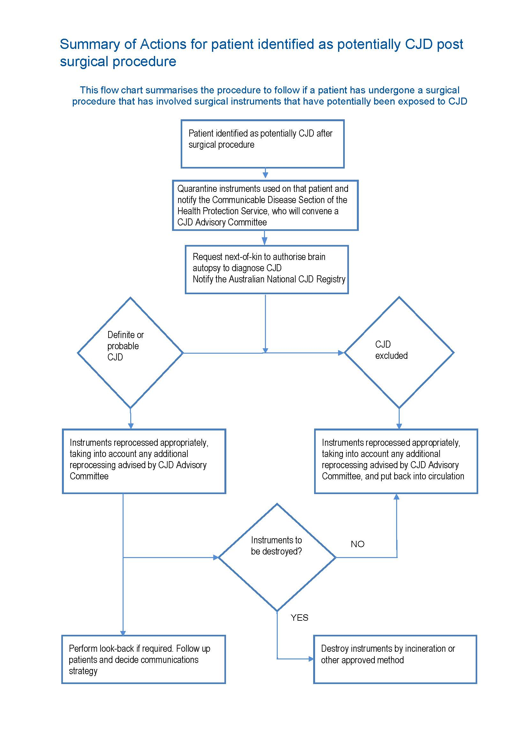
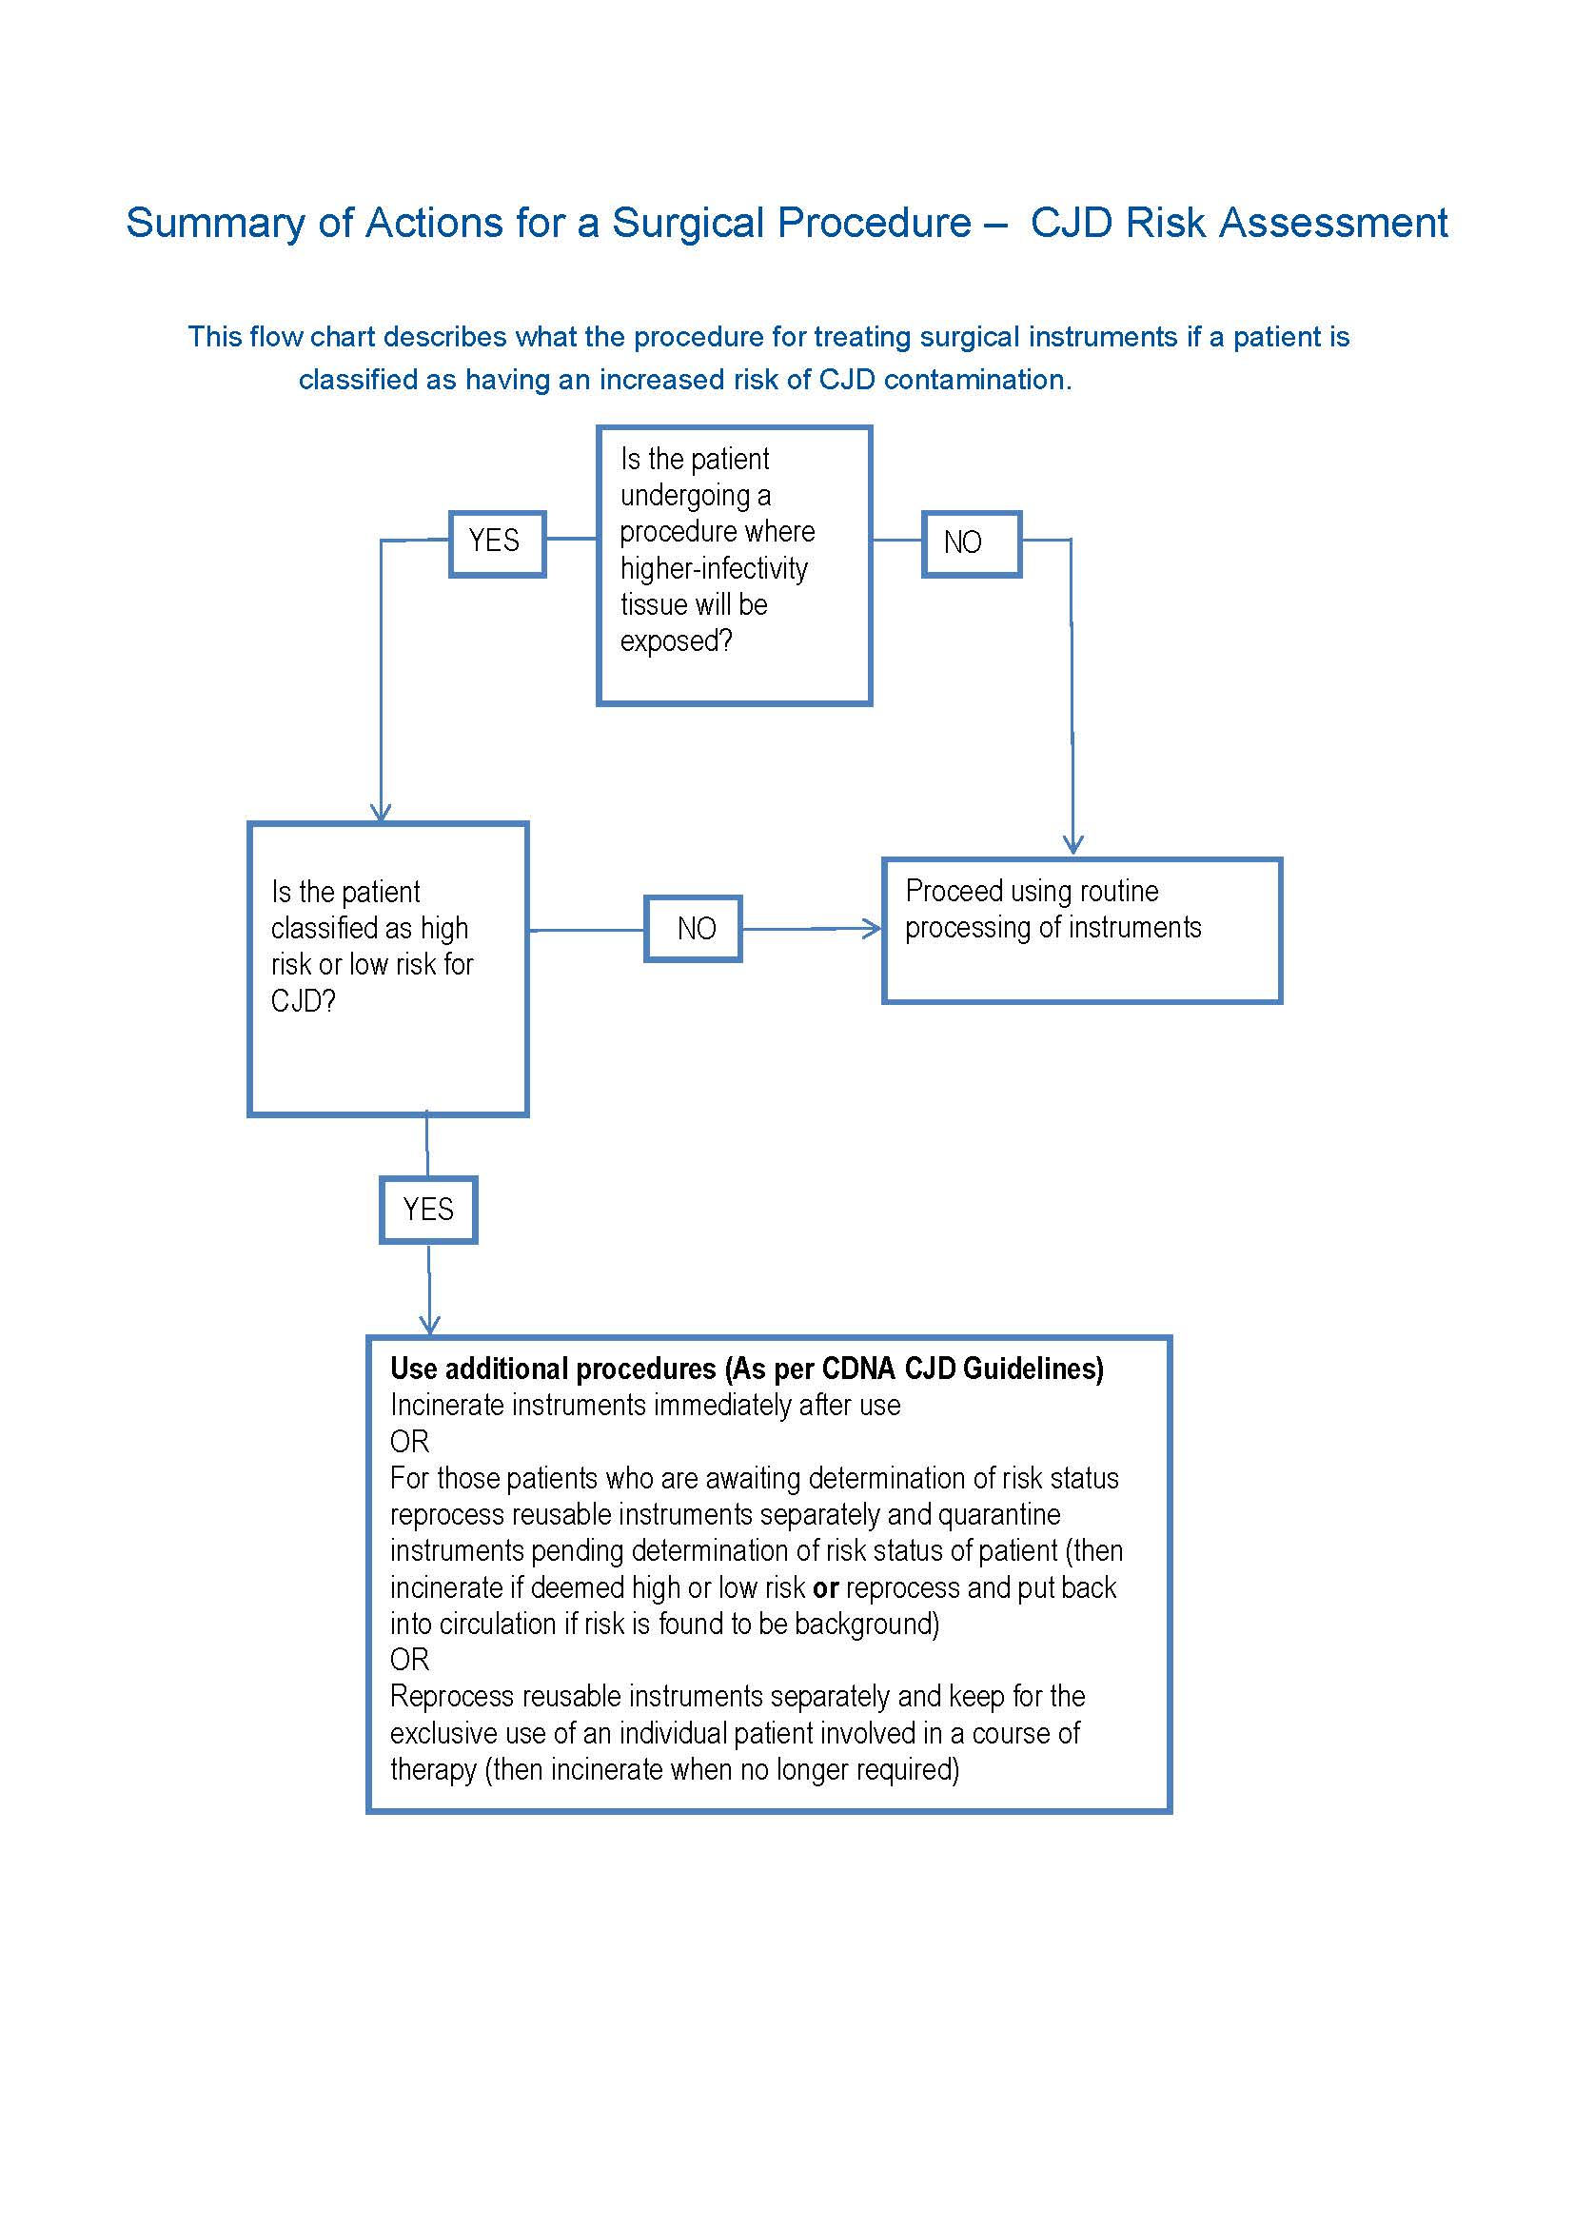

If a surgical procedure has been done on a patient at risk of CJD CHS staff and ACT Sterilising should follow the algorithm set out in the CDNA guidelines. If the question is raised on returning quarantined instruments to circulation a small committee must be formed to make such a decision. This committee could comprise of the following personnel:
- Appropriate executive governance as chair e.g. Chief Health Officer
- Infectious diseases physician
- Member of the treating team
- Infection prevention and control representative
- Public health officer
- Operating room representative
- ACT Sterilising representative
- Other members as deemed required to make this decision.

Table 1: Notifiable Infectious Diseases
- Anthrax | - LyssaVirus
- Arbovirus infection – | - Lyssavirus unspecified
- Dengue Fever | - Australian Bat Lyssavirus
- Ross River Virus  - Murray Valley encephalitis | - Duvenhague virus
- Japanese encephalitis | - Rabies (quarantinable)
- Arboviral encephalitis | - European Bat 1&2
- Barmah Forest Virus | - Malaria
- Arboviral infection (not elsewhere specified)  - Kunjin Virus  - Flavivirus | - Measles
- Avian Influenza (quarantinable) | - Meningococcal infection
- Botulism | - Mumps
- Brucellosis | - Paratyphoid
- Campylobacteriosis | - Pertussis
- Chlamydial trachomatis | - Plague (quarantinable)
- Cholera (quarantinable) | - Pneumococcal disease (invasive)
- Creutzfedt-Jakob Disease (all forms including classical and variant) | - Poliomyelitis – wild type and vaccine associated
- Cryptosporidiosis | - Psittacosis (Ornithosis)
- Haemloytic uraemic syndrome (HUSS)  - Haemophilus influenzae type b infection | - Q Fever
- Diphtheria | - Rotavirus
 | - Rubella and Congenital Rubella Syndrome
- Donovanosis | - SARS (quarantinable)
- Equine morbillivirus | - Salmonellosis
- Food poisoning (not elsewhere specified) | - Shigellosis
- Gastrointestinal illness cluster | - Shiga Toxin-producing and Vero Toxin-producing
- Giardiasis | - Smallpox (quarantinable)
- Gonococcal infection | - Syphilis
- Haemolytic Uraemic Syndrome | - Tetanus
- Haemophilus influenza serotype b (Hib) | - Tuberculosis
- Hepatitis A | - Tularemia
- Hepatitis B | - Typhoid
- Hepatitis C | - Varicella
- Hepatitis D | - Lassa
- Hepatitis (not elsewhere specified) if acquired through infection | - Marburg
- Human Immunodeficiency Virus (HIV) | - Ebola
- Influenza (laboratory confirmed) | - Unspecified or unclassified
- Legionnellosis | - Yellow fever
- Leprosy | - Yersiniosis
- Leptospirosis
- Listeriosis

Exclusion periods for healthcare workers exposed to or with an infectious condition

Procedure
The IPCU and OMU advise that all staff must meet the requirements of the Occupational Assessment, Screening and Vaccination Procedure (found on the policy register http://inhealth/PPR/default.aspx) by providing evidence of protection and/or screening against the specified infectious diseases; diphtheria, influenza, hepatitis B, measles, mumps, rubella, varicella, pertussis (whooping cough), tetanus and tuberculosis. Please see the procedure for further details. All existing CHS staff can access immunisations and immune status testing through the OMU.

Table 2 below indicates the required exclusion periods following infection with or exposure to communicable diseases for all CHS staff and requirements to be met before return to work.

Table 2 – Exclusion periods following infection or exposure to communicable diseases.
Organism | Exclusion From Patient Contact
Gastroenteritis including:  - Rotavirus virus  - Viral  - Small round virus  (Norovirus)  - Campylobacter  - Salmonella  - Cryptosporidiosis  - Shigella  - Giardiasis  - Undiagnosed diarrhoea (suspected infectious) | - To remain off duty for 48 hours after last symptom has resolved  - Health Care Workers (HCWs) diagnosed with Salmonella to seek advice from IPCU as to when they should return to work  - Food handlers with diarrhoea to seek medical advice and obtain a certificate prior to returning to work, in any scenario.
Chicken Pox and Shingles  (Varicella Zoster Virus) | - Unvaccinated or non-immune HCWs who are exposed to Chicken Pox or Shingles must be excluded from direct patient contact from day 10 until day 21 after exposure (staff could be redeployed to a non-clinical area)  - Staff with chicken pox must be excluded until all lesions are dry and no new lesions have developed for 48 hours  - All staff with Shingles must remain away from work until all lesions are dry or if commenced on appropriate antiviral medication, until 48 hours after the commencement of treatment, providing no new lesions have occurred in that time. Any lesion that is not dry after 48 hours of treatment must be covered with an occlusive dressing.  Note:  - Ensure unvaccinated or non-immune staff contact OMU to discuss immune status and immunisation  - If exposed to chicken pox or shingles HCWs should contact the OMU or seek medical advice  - HCWs who are non-immune should not care for patients with varicella zoster (Chicken pox or shingles)  - If a HCW develops chicken pox or shingles when having been on duty they must notify their Manager and the OMU immediately and seek medical advice.
Cytomegalovirus (CMV) | - No restrictions except for pregnant staff who should avoid direct prolonged contact with patients known to have CMV infection.
Conjunctivitis  (acute infectious) | - Remain off work for 48 hours after eye drops have commenced and discharge has ceased.
Hepatitis A | - Exclude for a least seven days after the onset of jaundice (see fact sheet for further information).
Herpes Simplex  (Cold Sores) | - HCWs should cover lesion whenever possible  - Exclude HCWs from caring for neonates, immunocompromised patients (severely neutropenic patients), operating rooms and delivery suite until 48 hours after anti viral medication has commenced or until lesion is dry  - A HCW can be deployed to a non-clinical area.
Influenza | - All staff must remain away from work:  - Until 72 hours after anti viral treatment has commenced or  - 7 days if untreated  AND  - All staff must be fever free for at least 24 hours before returning to work.
Methicillin Resistant Staphylococcus aureus (MRSA) | - All staff identified with MRSA must notify IPCU  - Staff must be excluded from work until all skin lesions have healed  - Staff must be off antibiotics before undertaking repeat tests.
Methicillin Sensitive Staphylococcus aureus (MSSA) | - Lesions must be covered otherwise HCWs should be excluded from direct patient care and food preparation  - HCWs with predisposing skin conditions should be rostered away from patients with staphylococcal infections.
Measles | - Exclude for at least 5 days from the appearance of the rash  - All staff suspected or identified with Measles must notify IPCU as contact tracing will need to be undertaken.
Mumps | - An infected staff member should be excluded from work for at least 9 days after onset of parotitis or swelling.
Pediculosis  (Head Lice) | - Exclude from patient contact or clinical work until the treatment has been commenced and HCW is free of lice.
Rubella | - All staff, especially female staff of child bearing age should ensure their immune status against Rubella is adequate.  - If non-immune staff member is exposed then they should be excluded from direct patient care from day seven after exposure until day 21.  - Staff with confirmed rubella should be excluded for 4 days after the appearance of the rash.
Tuberculosis (TB) | - A HCW will remain off work for a minimum of two weeks after commencing effective pulmonary TB therapy  - A clinical review by a specialist physician in tuberculosis management must be undertaken prior to returning to work.
Viral respiratory tract infections | - Exclude staff from contact with susceptible people until no longer symptomatic.
Whooping Cough (Pertussis) | - Excluded from work for at least five days after commencing effective antibiotic therapy or for 21 days after the onset if not receiving antibiotic treatment  - Non immune staff should contact OMU to discuss vaccination.
Streptococcal Infection | - Cover lesions and seek medical advice for systemic and local treatment.  - If lesions cannot be covered employees must not provide direct patient care nor prepare hospital food until 24 hours after commencement of appropriate antibiotic therapy  - Employees with pharyngitis/tonsillitis should avoid patient contact for at least 24 hours after starting appropriate antibiotic therapy
Scabies | - HCWs should not be rostered for work for at least 24 hours after commencement of effective treatment.

Code of dress or attire in restricted/semi restricted procedure areas
Surgical scrub attire is worn as part of multiple activities designed to promote and maintain a high level of cleanliness, hygiene and good infection control within the restricted/semi restricted area. ‘Street clothes’ are not to be introduced into restricted/semi restricted areas, and scrub attire is not worn outside the restricted/semi restricted areas (there maybe exceptional circumstances when this cannot be adhered to - please see below for further clarification) and must be not worn outside the Health Care Facility (HCF) as outlined in the Australian College of Operating Room Nurses (ACORN) Standards

All staff working in restricted/semi restricted procedure areas, such as operating rooms, cardiac catheterisation laboratory, endoscopy, and angiography suite or any area where other invasive operative procedures are performed must wear surgical scrub attire.

Scrub attire
When entering the restricted/semi restricted procedure areas all persons should wear appropriate scrub attire.
- Remove all outer garments, including t-shirts and spencers that will not be completely covered by the scrub attire. For effective HH clinical staff should not have clothing below the elbow.
- Don freshly laundered scrub attire, provided by the CHS.
- Scrub attire is to be changed daily or more frequently when wet or soiled. Clean scrub attire must be stored in the appropriate storage compartments only and not in staff lockers.
- Scrub attire should fit securely so inadvertent contamination of the sterile field does not occur.
- Clean jackets provided by CHS may be worn buttoned. These are to be changed daily, or more frequently when wet or soiled.
- Scrub attire must be laundered by the CHS linen contractor.

Scrub attire outside of restricted/semi restricted area
- Scrub attire is only to be worn within restricted/semi restricted areas. A hospital issue clean white cover gown worn with ties to the back or buttoned lab coat is to be worn over the scrub suit when it is urgent (e.g. emergency follow for patient review on ward) to leave the restricted/semi restricted procedure areas to attend clinical/ward areas and only for a short period of time. If the urgent issue is for a patient with a known MRO or an oozing wound then the staff member must change their gown and scrubs before returning to the operating room.
- If a person is leaving the restricted/semi restricted area for a longer period of time, e.g. to go to the cafeteria they should change back into their street clothes prior to leaving the restricted/semi restricted area or change into fresh surgical scrub attire when returning to the restricted/semi restricted area.
- If it is necessary to leave the restricted/semi restricted area attired in scrub attire it is essential to ensure the scrub attire is completely clean and free of blood and debris.

Headwear
- Head and facial hair coverings are to be made of low lint fabric and designed to minimise the shedding of hair and dandruff.
- Head and facial hair including sideburns should be covered when entering the restricted/semi restricted areas. Hair covers should be changed daily or when visibly wet or soiled. Personal hair covers are to be laundered daily by the CHS linen contractor.
- Bouffant or hood (balaclava) style hair coverings are preferred as skullcaps may fail to contain hair on side of head and nape of the neck. Facial hair such as a moustache must be covered when wearing a facial mask.
- Balaclavas must be worn for joint replacement surgery.

Footwear
- Footwear must be clean and meet occupational health and safety standards, i.e. well fitting with impervious and non-slip soles, enclosed forefoot and grip at the heel. It is preferred that dedicated footwear for operating rooms is worn.
- Gum boots and theatre shoes are not to be worn outside the restricted/semi restricted procedure areas.
- The routine use of overshoes is not recommended since bacterial numbers are increased on hands when applied or removed and an association has been established between surgical site contamination with bacteria of floor origin and the rate of surgical site infection.
- Theatre shoes/boots should be cleaned regularly, and whenever they are contaminated by blood or body fluids.
- Overshoes are recommended for visitors to the operating room(OR). Overshoes must be removed and disposed of prior to leaving the restricted/semi restricted area. If visitor’s shoes become soiled whilst in theatres they must be cleaned prior to leaving the operating rooms.

Jewellery
- All jewellery needs to be confined within the scrub attire or removed.
- All rings must be removed before scrubbing.
- Jewellery such as necklaces, earrings and other facial piercings, i.e. nose studs, eyebrow studs/rings and lip studs/rings, may be lost during a surgical procedure so should be removed or contained within scrub attire and hair coverings to avoid risk of falling into surgical field.
- Clinical staff with dermal piercings below the elbow, who were employed by the organisation prior to the implementation of this policy, must cover each piercing with an appropriate clean waterproof dressing prior to entering the restricted/semi restricted procedure areas.

Fingernails
Good hand and fingernail hygiene is essential in restricted/semi restricted areas.
- Fingernails must be short and clean.
- Skin integrity should be intact.
- Nail polish and nail additives must not be worn.
- Artificial/gel nails must not be worn.

Surgical masks
Surgical masks must be worn for personal protection and Work Health and Safety as well as for the protection of the patient undergoing surgery. All scrub personnel must wear masks. Filtration levels differ and masks should be selected according to the level of protection necessary.
- All staff including scrub personnel and anaesthetic team in the OR must wear masks if likely to be near a surgical field.
- Anaesthetic staff must wear masks during intubation and extubation procedures.
- Masks must be worn by all staff in the OR when power tools or irrigation under pressure (pulse lavage) are used.
- P2 masks are to be worn for suspected or known Tuberculosis (TB) cases, or patients known to have a respiratory illness.
- Masks should be removed by handling ties only and immediately discarded, followed by HH.
- Masks must not be saved by hanging masks around the neck or carrying in the pocket.
- Masks must not be reused; they are a single use item only.

Protective eyewear
Protective eyewear with side shields are provided by the hospital and must be worn for personal protection and Work Health and Safety:
- All scrub personnel must wear protective eyewear. Protective eyewear includes safety goggles or masks with splash shields. Prescription glasses without side shields are not considered as protective eyewear.
- Protective eyewear must be worn by all staff when power tools or irrigation under pressure (pulse lavage) are used.
- Anaesthetic staff must wear protective eyewear during intubation, extubation or splash prone procedures.
- Laser goggles, which meet Australian Safety Standards and are provided by the hospital, must be worn when the laser is in use.

Radiation protection
For further information refer to Radiation Management Policy.

When X-Ray is used:
- Scrubbed personnel must wear lead gowns and thyroid collars if less than 2 meters from the x-ray machine.
- All other personnel within the theatre or procedure room must wear a lead gown if less than 2 meters from the x-ray machine.

Occupational Medicine Unit procedures
- Blood Borne Virus - Occupational Risk Exposure Management
- Occupational Assessment, Screening and Vaccination
- Blood Borne Virus in Health Care Workers
Back to Table of Contents

Managing patients with infections or colonisation of pathogens

Multi-resistant Organism screening and clearance
At CHS, targeted screening is undertaken to identify patients / consumers colonised or infected with multi-resistant microorganisms (MROs).

Targeted groups include those transferred from or recent inpatients in other healthcare or residential care facilities, both in Australia and overseas, previous known MRO positive individuals and patients in selected high risk groups within the acute care setting, e.g. Intensive Care Unit. Patients known to have been an inpatient in overseas hospitals within the last 12 months are required to be placed into a single room and screened for MROs when admitted to Canberra Hospital.

MRO screening
Screening requirements are specified in Attachment A, which is based on patient risk factors for MROs.

If screening returns a positive sample, additional precautions should be applied and appropriate use of isolation and cohorting facilities should be implemented.
The treating medical officer or their designate should advise the patient of the MRO isolation.

When requesting screening it is important to accurately record on the pathology request form the MRO being screened for, the site of specimen collection and a clinical history, previous MRO isolation and recent antibiotics treatment.

Staff screening and decolonisation is currently not recommended for Methicillin-resistant Staphylococcus aureus (MRSA), Vancomycin-resistant Enterococci (VRE) or Multi-resistant Gram-Negative (GN-MRO) infections.

MRO clearance
The efficacy of a decolonizing regimen is dependent on the number of patient sites colonised with the MRO, presence of wounds, presence and extent of skin lesions, and foreign bodies, e.g. urinary catheters, percutaneous gastrostomy (PEG) tubes, haemodialysis lines.

There are specific requirements to be met before an individual can be declared ‘clear’ of a MRO. See Attachment A for clearance requirements for specific microorganisms in this document.

Healthcare facility transfer screening
It is the responsibility of receiving facility for rescreening; therefore patients are not to be rescreened prior to transfer.

Patients cannot be refused admission to acute care, nursing homes or long term care facility (LTCF) on the basis of their MRO status. There may however occasions when the facility, temporarily, does not have suitable accommodation for the patient.

If a patient is known to have a MRO, ensure the information is clearly documented and conveyed to the staff of the receiving healthcare facility.

Management of a patient suspected or identified with an MRO in Acute Care Settings

Equipment
- Additional precautions signage.
- PPE including disposable gown, gloves, masks, eye protection.
- Patient dedicated equipment.

Procedure
The use of transmission-based precautions is particularly important in containing MROs including MRSA, VRE, Carbapenem-resistant Enterobacteriaceae (CRE) and GN- MRO organisms. To limit or prevent the transmission of MROs in the acute care setting, patients with a known or suspected MRO are to be nursed using Contact precautions.

Core strategies
Patient accommodation:
- Single room with ensuite.
- Cohorting may only be undertaken following consultation with IPCU staff.
- The patient should be encouraged to stay within their room however if necessary, they may come out of the room for short periods but are not to go to shared facilities. Patients should clean their hand with ABHR prior to exiting room.

Hand Hygiene:
- Perform HH with antimicrobial hand wash or ABHR.
- HH must be performed on entering and leaving room, in addition to complying with the 5 moments of HH.

Personal protective equipment:
- PPE is to be worn whenever entering the patients rooms for any reason even if not having direct patient contact.
- A yellow disposable long sleeve gown is to be worn on entering the room or bed space.
- A gown is to be discarded prior to leaving the room or bed space or immediately on exiting the room.
- Gloves are optional for contact with patient, equipment and the immediate patient surroundings. If gloves are worn they may need to be changed whilst in the room depending on what patient care activities are being undertaken.
- Surgical masks are required if micro organisms are isolated from the sputum and whilst patient has a productive cough or a tracheotomy.
- If the MRO is in sputum and the patient has a cough, surgical masks should be worn by the patient when they are out of their room.
- Face / Eye protection is required by staff during procedures and activities likely to generate splashes or sprays of body fluids.
- Visitors are required to wear a disposable gown and perform hand hygiene on entering and leaving the patient room.

Patient equipment:
- Use dedicated equipment; single patient use items or clean equipment on removal from the room, e.g. Blood pressure machines, thermometers, lifters, single use oximeter probes.
- Patient notes and charts are not to be taken into the room.
- All equipment must be cleaned with detergent impregnated wipes before and after use on a patient.
- For Cystic Fibrosis (CF) patients, rinse all in-line and hand held nebulizers in water and air dry between treatments.
- CF patients use single dose vials for aerosolized medications. If a multi dose mediation vial is used, the manufacturer’s directions for handling, dispensing and storing must be followed precisely to prevent contamination and transmission of potential pathogens.

Inter hospital transfer:
- Ensure the receiving department and transport staff are aware of patients MRO status.
- If the MRO is in the sputum and the patient is coughing, the patient should wear a surgical mask during transport.
- Limit the amount of time that the MRO patient is waiting pre and post procedure.
- On arrival if possible place patient in a waiting area away from other patients.

Food services:
- A gown is not required for food delivery or pick-up.

Delivery:
- Gloves are not to be worn for food delivery however HH is to be attended on entering the ward/unit or if hands become soiled.
- If you are required to move items on the over table to enable placing of the tray then HH must be performed when leaving the patients environment.

Collection:
- Gloves are an option for pick up of used food trays. If using gloves, gloves are to be removed on leaving the room of the patient and HH to be performed.

Environmental Cleaning:
- Daily cleaning: one step cleaning product: detergent and bleach solution.
- Terminal cleaning: one step cleaning product: detergent and bleach solution.
- Rooms and beds of patients who stay longer than 7 days are to be cleaned every 7 days.
- Clean all portable equipment prior to removing it from the room.
- All patient magazines to be discarded into the waste.

Waste disposal:
- All waste to be placed in a clinical waste bin inside the patient’s room.

Additional requirements for the care of children with a MRO
- Children with an MRO should be encouraged to stay within their room.
- Children with an MRO should be discouraged from socialising with other children particularly immunosuppressed children.
- CF patients with an MRO should not socialise with other CF patients.
- For children with an MRO in their sputum and a cough, surgical masks should be worn when out of their room.
- Children with an MRO should not play with toys in the hospital playroom however if hospital toys are used they should be limited to those toys that can easily be cleaned and they must be readily cleaned after use. Best practice is for the patient’s own toys to be brought in from home and kept in their room.
- If patients with an MRO attend school it is important that they are placed in a defined area away from other children.
- Only one patient with CF and an MRO can attend the hospital school at a time.
- Adolescents with an MRO may need to be allocated time in the activities room when no other patients are allowed to use the room.

Outpatient clinic appointments
- Children who have an MRO and who need to attend clinics should be placed in a defined area / consult room away from other children.
- Patients with CF who have an MRO and who need to attend specific CF outpatient clinics should be placed in a defined area/consult room, to limit contact with other CF patients.

Notification requirement
- It is the responsibility of the treating medical officer or their designate to advise the patient of the MRO isolation.
- The Microbiology Department will contact IPCU or the admitting ward or treating doctor (after hours) of any newly diagnosed MRO patients.
- The Microbiology Department will provide the infection prevention and control unit with a computer generated report on all significant microbiology results on a daily basis.
- During business hours the Microbiology Department will notify infection prevention and control unit of any MROs. IPCU will notify the appropriate clinical area to ensure additional precautions are implemented and will add the alert onto the patient’s record in the ACT Patient Administration System.
- During business hours an Isolation precautions notification sticker will be placed in the clinical notes of admitted patients identifying the microorganism, and the additional precaution requirements.
- Intensive Care Unit patients will have an electronic sticker placed in the Metavision record.
- IPCU will assist with the correct placement of the patient and the education of staff if required.
- Newly diagnosed MRO patients are to be given a copy of the relevant MRO patient information pamphlet.

Outside business hours the Microbiology Department will directly contact the appropriate clinical area with a positive result. It is the responsibility of the clinical staff member (in the ward/clinical area) receiving the notification to document the notification into the patient records.

Management of a patient suspected or identified with an MRO in a multi bed room

Equipment
- Additional precautions signage.
- PPE including disposable gown, gloves, masks, eye protection.
- Patient dedicated equipment.

Procedure
Patients who are suspected of having or are newly diagnosed with a MRO require isolation and additional transmission based precautions implemented:
- Move the patient to a single room with an ensuite or dedicated toilet and commence contact precautions.
- Place appropriate infection control signage at the room door.
- Wait for confirmation of results:
- If results are negative, the patient can be returned to the two or four bed room unit and isolation precautions ceased.
- If results are positive the patient will remain in isolation for the duration of their hospitalisation.
- If screened contacts are positive, the IPCU may consider more extensive screening of the ward patients and / or environmental sources.

Management of other patients in the room
- Patients who have been in the same room as a confirmed or suspected patient with MRO for greater than 48 hours are to be screened for the MRO that has been identified in the other patient.
- Patients in contact with the suspected or confirmed patient with a MRO for less than 48 hours do not require screening as it takes around 48 hours for a patient to become colonised.
- There is no need to isolate or confine the screened patients awaiting results who are housed in the room. Contact precautions are not required for these patients until the results are finalised. However it is preferable that this group remain together pending results:
- If any of these cohorted patients become positive move them to the single room as above.
- If the patient is negative, no further action is required.

Management of the vacated bed space
- Terminally clean the bed space left by the patient with suspected or confirmed MRO patient.
- The vacated bed space is to remain quarantined until the screening results of the other patients in the room are known. This is to reduce the possible risk of infection transmission from the remaining patients in the room, should they test positive for an MRO.

Management of patients suspected or identified with a MRO in the Subacute Unit

Procedure
Subacute Units include Rehabilitation Independent Living Unit (RILU) or a Mental Health Unit. The subacute units require adaptation of infection control practices for the management of MROs in order not to restrict the positive outcomes of their admission. A subacute patient should be medically and surgically stable and where possible not have any of the following:
- Intravenous (IV) cannula
- Recent open surgical wound (no stitches or clips still in place)
- Skin ulcers or lesions with uncontained discharge.

Placement of patients
- A single room or cohort room is preferred for all patients with confirmed or suspected MROs.
- Gloves and gowns must be worn for direct patient care when contact with body fluids is likely, such as when a patient has diarrhoea, faecal incontinence, urinary incontinence, uncontained sputum or a discharging lesion.

Movement of patients within the unit
- Patients with a confirmed or suspected MRO should not be restricted from participation in social or therapeutic group activities within the unit.
- Prior to leaving their room and before joining others for meals, recreation and therapy sessions, patients with an MRO will be instructed to perform HH by either using the ABHR or wash their hands with soap and water, will have wounds covered and have suitable management of incontinence.
- The importance of hand-washing, especially after using the toilet, should be explained and, if necessary, be supervised.
- Any body fluid spills (including sputum) should be cleaned up immediately.

Visitors
- Visitors should be instructed to perform HH by either using the ABHR or wash their hands with soap and water when entering and leaving the patient’s room.
- Ask visitors not to visit other patients within the healthcare setting after visiting the patient with an MRO.

Screening of patients in a Subacute Unit
- Patients admitted to a Subacute Unit from another healthcare facility should be screened for MROs on admission.
- Repeat screening of known MRO patients should be undertaken as outlined in Section 6.1.3 – Healthcare facility transfer screening.

Transfer of MRO patients from Subacute to an Acute Care Unit
Every time an MRO patient (whether infective or colonised) is transferred from the Subacute Unit to an Acute Care Unit the following guidelines apply:
- The patient must be admitted to a single room and placed into contact precautions.
- IPCU must be informed of transfer.

Vancomycin Resistant Enterococcus - probiotic treatment
- Vaalia ™ yoghurt
OR
- Probiotic medication containing Lactobacillus rhamnosus GG (for Renal patients only)

Procedure
This procedure is for adult patients who have a positive VRE microbiological test at CHS.

Probiotic treatment is not recommended for patients who are immunosuppressed or neutropenic and they should only use the probiotic yoghurt after consultation with their doctor.

Yoghurt treatment is unsuitable for renal haemodialysis patients. Following consultation with their treating doctor these patients may take specific oral probiotic tablets.

Probiotic treatment is to be commenced when the patient is confirmed VRE positive. Only yoghurt containing Lactobacillus rhamnosus GG, such as Vaalia, is suitable as a treatment regime for VRE.

Probiotic yoghurt treatment is ordered for the patient and the process is as follows:
- A minimum of 150g Vaalia™ yoghurt containing Lactobacillus rhamnosus GG to be prescribed on the medication chart and given orally to patient daily
- Notify the Nutrition Department of any newly diagnosed or admitted VRE patients
- The Nutrition Department coordinates the issuing of the probiotic yoghurt containing Lactobacillus rhamnosus and this will be supplied by Food Services during the morning tea round with the patients name clearly labelled on the container.
- NB: Probiotic yoghurt is available on all appropriate diet types for general hospital patient menus.

Duration of yoghurt therapy
- The yoghurt is to be given daily for a total of four weeks.
- Re-screen the patient for VRE at the end of the four week period by taking a perianal swab plus a specimen from any other known positive site, e.g. urine or wound.

If patient remains positive for VRE:
- Yoghurt therapy should continue for an additional four weeks.
- The patient is to continue with additional (contact) precautions.
- Repeat perianal-screening swabs for VRE plus a specimen from any other known positive site, e.g. urine or wound at the end of the second four week period.

For a patient to be confirmed VRE negative post treatment
- While on yogurt therapy the patient must have two consecutive negative swabs over an eight week period.
- After consultation with the IPCU the patient may be removed from isolation, patient can continue the probiotic therapy or the probiotic therapy may be ceased.
- Notify the Nutrition Department that the yogurt is not longer required.

Management of patients suspected or identified with an infectious illness in outpatient settings

Procedure
Patients with a suspected/confirmed respiratory/airborne infection should be discouraged from attending routine appointments unless absolutely necessary.

When patients are required to attend outpatient clinics for testing e.g. they have been directed to the clinic by HPS or their doctor, then they should telephone in advance to the clinic so appropriate isolation arrangements can be made. For patients requiring pathology services, they may be directed to a specific collection centre (i.e. not necessarily their closest) where they can be most safely managed.

The use of transmission-based precautions is particularly important in containing infectious microorganisms which are transmitted via the droplet or airborne routes such as measles, chickenpox, respiratory viruses, tuberculosis and mumps.

To limit or prevent the transmission of infectious microorganisms in the outpatient setting, patients with a known or suspected infectious illnesses are to be isolated or at least kept away from other patients visiting the clinic.

Standard and Additional precautions are the core infection prevention and control strategies to be implemented when a transmissible infection is suspected or identified.

Droplet precautions
Droplet precautions are applied to patients with suspected or known to be infected with a pathogen that can be transmitted by droplet route. These include, but are not limited to:
- Respiratory viruses such as Influenza, Parainfluenza Virus, Adenovirus, Respiratory Syncytial Virus, Human Metapneumovirus
- Bordetella pertussis.

Actions:
- Perform HH before and after touching the patient and after contact with respiratory secretions and contaminated objects/materials. Ensure hands are washed using soap and water when they are visibly soiled with for e.g. blood or body fluids.
- Place the patient, wearing a surgical mask, in an examination room with the door closed as soon as possible (prioritize patients who have excessive cough and sputum production).
- If an examination room is not available the patient is to be provided with a surgical facemask and placed in a separate area as far from other patients as possible while awaiting care.
- Clean and disinfect the examination room prior to seeing the next patient in the same room.
- PPE use:
- Staff are to don a surgical mask prior to or upon entering the examination room.
- If substantial spraying of respiratory fluids is anticipated, such as during the taking of a flocked swab, gloves, gown, goggles (or face shield in place of goggles) and a P2/N95 mask must be worn.
- Instruct the patient to wear a facemask when exiting the examination room, avoid coming into close contact with other patients, and practice respiratory hygiene and cough etiquette.

Airborne precautions
Apply to patients known or suspected to be infected with a pathogen that can be transmitted by airborne route including but are not limited to:
- Tuberculosis
- Measles
- Chickenpox (until lesions are crusted over).

Actions:
- Perform HH before and after touching the patient and after contact with respiratory secretions and/or body fluids and contaminated objects/materials. Ensure hands are washed using soap and water when they are visibly soiled with for e.g. with blood or body fluids.
- Have the patient enter the facility through a separate entrance if possible, e.g. dedicated isolation entrance, to avoid the reception and registration area.
- On arrival the patient is to be immediately isolated by:
- Providing a surgical mask to the patient.
- Placing the patient immediately in an examination room with the door closed.
- Instructing the patient to keep the surgical mask on while in the exam room and to change the surgical mask if it becomes wet.
- Staff are to wear a P2/N95/Duck bill respirator when caring for the patient. The respirator should be donned prior to room entry and removed after exiting room.
- If substantial spraying of respiratory fluids is anticipated, such as the taking of a flocked swab, gloves, gown and goggles (or face shield in place of goggles) plus a P2/N95/Duck bill respirator must to be worn.
- Instruct the patient to wear a surgical mask when exiting the examination room, avoid coming into close contact with other patients and practice respiratory hygiene and cough etiquette.
- Once the patient leaves the examination room should remain vacant for generally one hour before anyone enters.
- Clean and disinfect the examination room prior to seeing the next patient in the same room.

Notification requirement
- Outpatient staff are required to notify the IPCU when they are about to or have attended to a patient who is suspected to have a infectious illness, as per notifiable section above.
- Outpatient staff are to provide IPCU with a list of patients, staff and patient / carers attending the clinic at the time the infected patient presents for testing.

Negative Pressure or Positive Pressure rooms

Note: Ward 14A was commissioned as a positive pressure ward in November 2019.

Negative and positive pressure rooms are designed to protect staff and patients when a patient has a disease or condition (e.g. Tuberculosis, Varicella (chicken pox), Measles or is neutropenic) that require more than Standard Precautions.

Patients with these diseases/conditions will require physical separation from other patients by placing them in a single room to reduce contact and/or airborne spread of the infective agent or to protect them from general pathogens (neutropenic patients).

Selected patient rooms or Ward 14A have been provided with air pressure control to maintain either a negative or positive room air pressure.

Room air pressure, or pressure differential, is created when one space (corridor/ante room) is at a different pressure than an adjoining space (patient room). When a pressure differential is created between two spaces, air is forced to flow from the higher pressure space to the lower pressure space. The direction of air flow is one component of room air pressure. The second component of room air pressure is the speed or how fast is the air moving between the two spaces.
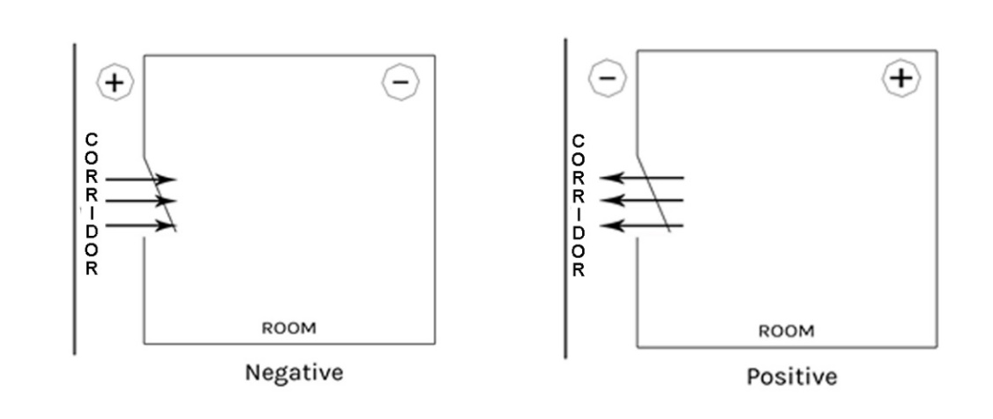
Negative room pressure in a room is supplied by the air ventilation system that generates negative pressure to allow air to flow into the isolation room, but not escape from the room. Air will naturally flow from areas with higher pressure to areas with lower pressure, thereby preventing contaminated air (e.g. airborne microorganisms) from escaping the room, such as entering the corridor/ante room. Typically air flows from the corridor/ante room into the negative pressure room, ensuring that contaminated air cannot escape from the negative pressure room to other parts of the ward. This technique is used for isolation of patients with airborne contagious diseases, such as Tuberculosis, Varicella (chicken pox), and Measles.

Positive Room/ward pressure in a room/ward that is supplied by the air ventilation system that generates positive pressure greater than the environment that surrounds that room. This technique is used to prevent transmission of pathogens from the outside environments to profoundly immune-compromised patients, such as severely neutropenic patients and allogeneic bone marrow recipients. Air will flow out of the room instead of in, preventing any airborne microorganisms (e.g. bacteria, etc.) from entering the room.

Negative Pressure or Positive Pressure Room/Ward features
- The Negative Pressure room will continue negative air flow at all times.
- The Positive Pressure room/ward will continue positive air flow at all times.
- All Negative Pressure or Positive Pressure Rooms/wards will have pressure alarms installed.
- There is no manual over-ride for adjusting the pressures in these rooms.
- An alarm indication is displayed on the annunciator panels and staff station terminal within the respective ward identifying the room in which the pressure loss/gain has occurred.

Infection prevention and control
IPCU are required to know the location of all Negative Pressure and Positive Pressure rooms throughout CHS and to assist bed management in correctly allocating patient’s rooms with an infectious disease.

IPCU should be notified when a Negative Pressure or Positive Pressure room or Ward 14A fails to achieve required pressure.

Property Management and Maintenance Unit, Infrastructure Support
Property Management and Maintenance Unit are to ensure that ongoing maintenance and testing of Negative Pressure and Positive Pressure rooms is undertaken and reported to HAI Standard Group.

Property Management and Maintenance Unit are responsible for the initial education of Healthcare workers in the reading and interpreting of monitoring instrumentation regarding pressure variants, system functions and interpretation of the alarming system.

Clinical Staff
Ward Clinical Nurse/Midwife Consultants (CNC/CMCs) are responsible for ensuring ward/unit performance monitoring and compliance to the procedure. Clinical Staff are expected to maintain a process of daily monitoring, recording and reporting of non-compliance in accordance with this procedure.

Clinical staff are to report errors detected to Property Management and Maintenance as they occur.

CNC/CMCs and Bed Management are to allocate correct isolation rooms in accordance with clinical isolation requirements.

Clinical staff should be educated in the reading and interpreting of monitoring instrumentation regarding pressure variants and system functions. This is a Ward/Unit specific induction that includes education on the interpretation of the alarming system. Clinical Development Nurses/Midwifes are to facilitate 6 monthly in-service training sessions.

Ward/Unit performance monitoring
Clinical staff need to maintain a process of daily monitoring and recording of the pressure indicated on the pressure gauge located just outside the entrance to the room. The doors of the room (and the anteroom) need to be closed prior to the monitoring of the pressure.

Recording system needs to indicate:
- Daily room pressure checks
- Alarming system functional = YES/NO (if NO, maintenance request completed = YES/NO)
- Annual Service and Maintenance - label – dated and signed.
- A documented record of daily performance check shall be available and kept at the Nurses and Midwifery Station.

Negative Pressure or Positive Pressure room/ward:
When the room is used for a patient that requires a Negative Pressure or Positive Pressure room, the key controlled alarm is to be activated.

When the Negative Pressure or Positive Pressure room is not used for a patient that requires a Negative Pressure or Positive Pressure room the key controlled alarm can be deactivated.

Each Negative Pressure or Positive Pressure room is fitted with a functional pressure gauge outside the room. The pressure gauge is either:

- Negative Pressure analogue gauge:
Alarm Panel -  Red light indicate insufficient Negative Pressure inside room | Pressure Gauge –  Sufficient Negative Pressure = between -5 to -10 Pascals. | Pressure Gauge –  Insufficient Negative Pressure = less than -5 Pascals
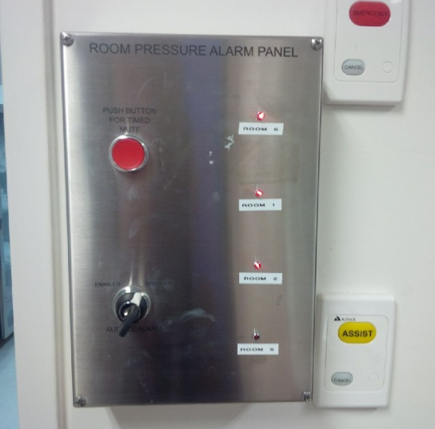 | See gauge on next column | 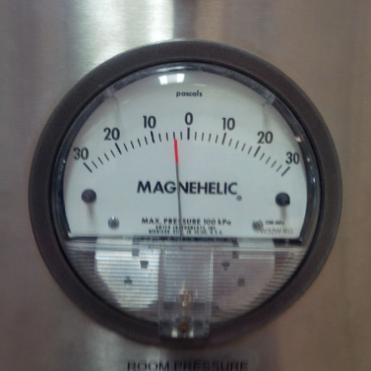

Initiating key controlled alarm for patient requiring Negative Pressure Isolation
Step | Action
1 | To set up room before admitting the patient, the alarm is to be activated.  To enable the alarm of the Negative Pressure room access the alarm key. The key to enable the alarm is located with the ward/unit Dangerous Drug (DD) keys.  Close the door to the Negative Pressure room.  Complete the procedure for checking negative room as in flowchart of daily Check Sheet.  Start the alarm by turning the key/switch from ‘off’ to ‘on’.  Remove the key - the Negative Pressure room alarm has now been activated.  If this does not occur contact PMM (out of hours via switch board).
2 | Once the patient is in the room, access should be via the anteroom door when possible.  Ensure both the main door and anteroom door remain closed at all times.  N.B. The anteroom doors are designed to allow only one door to be opened at any one time.
3 | If the Negative Pressure room alarm is no longer required, (i.e. patient is determined to be non-infectious) turn the key for the alarm on the panel to ‘normal/off’.
Negative Pressure room process when patient who had a clinical requirement for a Negative Pressure room is discharged.
The following steps must be undertaken following discharge of an infectious patient.
The room CANNOT BE USED FOR NEW ADMISSIONS until the steps have been undertaken in the following order.
4 | When the patient is discharged, close the door and leave vacant for 30 minutes prior to terminal clean (to ensure transmission is reduced).
5 | If Ward/unit staff or contracted staff enter the room during this 30 minutes period they must wear a N95/P2 respirator particulate mask.
6 | Using the alarm key, turn the key to alarm off position.
7 | Complete terminal clean

Positive Pressure analogue gauge:

Alarm Panel -  Red light indicate insufficient Positive Pressure inside room | Pressure Gauge –  Sufficient Positive Pressure = between +2 to +10 Pascals. | Pressure Gauge –  Insufficient Positive Pressure = less than +2 or greater than + 10 Pascals

Initiating key controlled alarm for patient requiring Positive Pressure Isolation
Step | Action
1 | To set up room before admitting the patient, the alarm is to be activated  To enable the alarm of the Positive Pressure room access the alarm key. The key to enable the alarm is located with the ward/unit DD keys.  Close the door to the Positive Pressure room.  Complete the procedure for checking Positive Pressure as in flowchart of daily Check Sheet.  Start the alarm by turning the key/switch from ‘off’ to ‘on’.  Remove the key - the Positive Pressure room alarm has now been activated  If this does not occur contact PMM (out of hours via switch board).
2 | If the Positive Pressure room alarm is no longer required, turn the key for the alarm on the panel to ‘normal/off’.
Positive Pressure room process when patient who had a clinical requirement for a Positive Pressure room is discharged
Step | Action
3 | Using the alarm key, turn the key to alarm off position.
4 | Standard cleaning required

Negative Pressure or Positive Pressure electronic gauge:
E.g. used in Centenary Hospital for Women and Children (CHWC)

Electronic Gauge Pressure Alarm
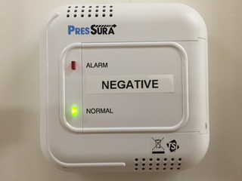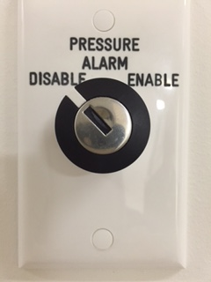

Initiating key controlled ‘Pressure Alarm’ for patient requiring Negative Pressure or Positive Pressure rooms
Step | Action
1 | To set up room before admitting the patient, the ‘Pressure Alarm’ is to be activated.  To enable the ‘Pressure Alarm’ of Negative Pressure or Positive Pressure room, use the alarm key. The key to enable the alarm is located with the ward/unit DD keys.  Close the door to the pressure room.  Complete the procedure for checking Negative Pressure or Positive Pressure room as in flowchart of DAILY CHECK Sheet.  To enable the alarm by turning the key/switch from ‘Disabled’ to ‘Enable’.  Remove the key - the Negative Pressure or Positive Pressure room alarm has now been activated.  If this does not occur contact Property Management and Maintenance (out of hours via switch board).
Negative Pressure room process only
2 | Anterooms are only required for Negative Pressure rooms.  The anteroom doors are designed to allow only one door to be opened at any one time.  Once the patient is in the room, access should be via the anteroom door whenever possible.  Ensure both main door and anteroom door remain closed at all times.
Negative Pressure room process when patient who had a clinical requirement for a Negative Pressure room is discharged.
3 | When the patient is discharged, close the door and leave vacant for 30 minutes prior to terminal clean.
4 | If Ward/unit staff or contracted staff enter the room during this 30 minutes period they must wear a N95/P2 respirator particulate mask.
5 | Complete terminal clean
Positive Pressure room process when patient who had a clinical requirement for a Positive Pressure room is discharged
2 | Using the alarm key, turn the key to alarm ‘Disabled’ position.
3 | Standard cleaning required

Management of Multi–resistant Organisms in Operating Theatres

Preparation of Operating Theatre and surrounding area
- All staff working in the OR and surrounding areas to perform HH according to the 5 moments of HH.
- ABHR is to be available in the anaesthetic bay.
- Any items taken into the OR during the operations will be considered contaminated. All equipment used in the OR must be cleaned between patients and instruments will need to be reprocessed even if not opened.
- Reduce the non essential equipment and place in the anaesthetic bay.
- Anaesthetic Nurse to confer with Anaesthetist and select sufficient stock for immediate use and place Schedule 4 & 8 Drug Registers in the anaesthetic bay.
- Clinical waste bins are to be available to dispose of all PPE exiting the OR.
- Set up a small trolley with yellow gowns, range of non sterile gloves (boxes), shoe covers, ABHR and detergent wipes.
- Outside Scout should locate themselves in the scrub bay during the case to:
- Ensure staff are wearing correct attire for contact precautions.
- Remind staff of the need to clean equipment with detergent wipes if it is removed during the procedure e.g. x-ray equipment.
- Ensure compliance with HH.
- Personnel keep pagers and mobile phones within their scrub attire or leave them on the outside scout trolley. These items should be wiped over after each patient.

Management of patients with Tuberculous (TB):
Pulmonary TB:
Follow all instruction for management of MRO patients
- Identify where the patient is in their journey. If they are still infectious consider postponing their surgery until the patient has had appropriate treatment to consider them non-infectious
- If surgery is required, surgery should be scheduled out of hours to reduce the number of patients and staff exposed to the patient with TB
- Before taking the patient to theatres, the theatre team must be notified as to the infectious status of the patient
- If considered infectious, the patient must wear a surgical face mask when transferred throughout the hospital
- Surgery should take place in a negative pressure theatre and staff must wear appropriate PPE including a P2/N95 respirator mask. If a negative pressure theatre is not available liaise with Infectious Diseases and Respiratory treating teams to identify where the patient is in their infectious journey to discuss if the operation should go ahead, in a normal theatre with staff wearing a P2/N95 mask.
- Recovery of the patient with an infectious respiratory disease takes place in the theatre before transfer to the ward.
- For a patient with active TB the theatre must sit for one hour before cleaning occurs to ensure enough air exchanges have taken place. Cleaners are to wear a P2/N95 respirator mask. For patients who are considered non-infectious cleaning can take place immediately and the room can be reused straight away.

Extrapulmonary TB:
Operating on the TB lesion
- Surgery should take place in a negative pressure theatre with staff wearing appropriate PPE including a P2/N95 respirator mask If a negative pressure theatre is not available liaise with Infectious Diseases and Respiratory treating teams to identify where in their infectious journey they are to see if the operation should go ahead in a normal theatre with staff wearing a P2/N95 mask.
- Patients who have been cleared of pulmonary TB do not need to wear a mask when being transferred to theatre
- Patients will need to be recovered in the theatre
- The theatre will be rested for one hour before cleaning to ensure enough air exchanges have taken place
- If the patient requires the wound to be redressed post operatively, staff are to wear appropriate PPE and P2/N95 respirator mask.

Transport of the MRO patient within Perioperative Unit
- The patient will arrive in Unit and be taken directly into the OR without accessing the holding bay or anaesthetic bay.
- It is important to remember not to send for the patient early and to ensure all staff are aware of the patient’s MRO status.
- Personnel caring for the patient are required to wear PPE for standard and contact precautions, e.g. mask, yellow gown, gloves and eye protection.
- Do not place clinical notes or equipment on patient’s bed.

Management during and on completion of surgical procedure for the patient with MRO
- Remember that all equipment that is removed from the OR must be cleaned. This can be done with a detergent wipe and the equipment should then be dried with paper towel or a clean cloth. Items then need to go to pre rinse are transported for reprocessing or for disposal.
- If staff need to leave the room during a procedure, remove PPE and perform HH. Don new PPE on return to the OR.
- Minimise all movement from OR to anaesthetic bay. If items in the anaesthetic bay need to be accessed, remove gloves only, clean hands with ABHR and touch only the items required. Reapply gloves and re-enter the room.
- After transferring patient onto OR table, strip all linen from patient bed and push bed into bed bay outside of OR. Request outside Scout to page the Hospital Assistant (HA) to clean the bed as per hospital protocol. An MRO/Contact sign is placed onto the bed to alert the HA.
- Personnel attempting to enter OR via the anaesthetic bay should be requested to enter via the scrub bay where gowns and gloves are available.
- Notify Post Anaesthetic Care Unit (PACU) prior to patient transfer for MRO patients only.
- Assist with patient transfer onto ward bed.
- Discard all disposable equipment present in the OR into the contaminated waste including unused rolls of tape.
- Transfer the sharps bin across to the scrub staff for the disposal of sharps. Close the bin and discard on the instrument trolley.
- Send all re-usable stock on the scrub trolley to pre-rinse for reprocessing.
- Leave the anaesthetic drug trolley in the anaesthetic bay for the HAs to clean routinely.
- All waste is placed in yellow waste bags. Seal up rubbish bags.
- Staff leaving the OR should remove PPE and perform HH.
- Ensure the Schedule 4 & 8 Drug Register is signed by the Anaesthetist only after they perform HH.

Scrub nurse responsibilities
- Suck any remaining fluids into the sucker, seal and discard in contaminated waste and double bag.
- Contain all used equipment within the drapes on the instrument trolley as per routine practice. If not sufficiently contained, use a plastic drape to achieve complete coverage.
- Remove sterile gown and gloves, clean hands with ABHR and don yellow gown and non-sterile gloves.
- Write up paperwork and prepare to escort patient to designated isolation bay in PACU for MRO patients or to the ward for TB Patients. All paperwork and X-Rays should be carried to PACU and not placed on the patient bed, to avoid risk of contamination of the notes.
- After patient handover in PACU and all care is completed, remove PPE and discard in the clinical waste bin in the isolation bay. Perform HH in isolation bay.
- Restock kit with photocopies of signs and lists as necessary.
- Contact a HA to:
- Clean all equipment and furniture that is outside of the OR first, e.g. anaesthetic drug trolley in the anaesthetic bay.
- Clean all equipment in the OR thoroughly with neutral detergent solution. This includes cables and foot pedals.
- Contact the cleaners to wash the OR floor and surfaces covered by their duties.
- The Team Leader will check the OR for a plastic bag marked with Contact/MRO sign which may contain items the HA was unable to wash.
- Some consideration may be given to variations from this procedure if large financial loss is to be avoided, e.g. an implantable item taken into the OR and not opened may be considered for decontamination:
- If the outer wrapper over the non sterile cardboard box is waterproof and intact, a decision could be made to wash the outer wrapped and retain the implant.
- Advice should be sought from the IPCU in any circumstance outside of the procedure.

Caring for patients in Post Anaesthetic Care Unit that require infection control precautions
- It is important that PACU staff are made aware of the MRO or TB status of the patient by the transferring team.
- Where possible place patients identified with a MRO or TB in a designated cubicle within PACU.
- If the designated cubicle is not available then the patient with the MRO or TB should be cared for with ’defined care’.
  - Defined care means that the patient is to be located in the PACU where the least number of staff would come into contact with the patient therefore reducing the risk of exposure to both patients and staff within PACU.
  - An additional precaution card should be attached to the curtains to act as a communication sign to all staff.
  - A temporary PPE Station should be located at the entrance to the defined area.
- All staff must perform HH as per the 5 moments of HH, this includes before putting on gloves and after removing gloves.
When PACU is unable to accommodate a preoperative patient and holding bay is empty then the patient can be cared for in holding bay utilising the above procedure.

Outbreak management
An outbreak is defined as one (1) above the normal rate.

Outbreak management team members
If an outbreak is suspected IPCU staff are to alert their manager who in turn will inform higher hospital management and the Emergency Management Coordinator. If required an outbreak management meeting is to be called. A code yellow to be called at this time. Responsibility for responding to an outbreak is managed by an Outbreak Management Team (OMT).

Key personnel include:
- Executive Representative (Chair)
- Emergency Management Coordinator
- Infectious Disease Physicians
- Representative from IPCU
- Microbiologist
- Nursing Executive Representative
- Shift Co-ordinator and/or Bed Flow manager
- CNC/Assistant Director of Nursing (ADON) for affected area
- Appropriate Disease Specialist
- Risk Management Representative
- Work Health Safety (WHS) representative
- Pharmacy representative if involving drug prophylaxis or utilisation
- Public Affairs/Media relations
- Local Public Health staff from the HPS - Infection Control Co-ordinator and/or Disease Surveillance Manager
- Catering, laundry, sterilizing representative
- Cleaning representative
- Environmental officer
- Other liaison members would be included depending on the nature and scope of the outbreak.

It is expected that all members of this team would participate regardless of the nature or specific geography of the exposure.

Preliminary phase
- Infection control precautions should be implemented immediately based on findings.
- Confirm the outbreak.
- Establish an early case definition – this may include clinical symptoms and / or laboratory confirmation.
- Collect further clinical epidemiological and laboratory findings.
- If an outbreak is confirmed:
- Convene an OMT and nominate an Outbreak Co-ordinator.
- Establish email contact list.
- Set up spread sheet for tracking purposes.
- Notify HPS / Public Health Unit / Laboratory and keep a line list up to date.
- Regular-daily (initially) communication – email, face to face meetings to stakeholders/media for updates/changes.

Control measures
- Signage indicating outbreak to be placed on door at entrance to ward
- Obtain signage from the IPCU.

Nursing care
- Additional precautions and PPE will depend on case definitions, however most commonly the following will apply:
- Patients where possible are to be placed in contact precautions in single rooms with ensuite.
- Staff must wear PPE (yellow disposable long sleeved gowns, gloves and mask (P2/N95/Duck Bill respirator)).
- Gowns are to be discarded prior to leaving the room.
- In the case of a four bed room then PPE must be changed between patients.
- Gowns and gloves are single use only.
- Face and eye protection should be worn where there is a likelihood of splash of body fluids.
- Dedicated equipment for single patient use or equipment must be cleaned on removal from patient’s room.
- Notes and charts are not to be taken into the room.
- Cohorting of patients may be necessary, as decided by the IPCU.

Cohorting
- During suspected or confirmed outbreaks, e.g. norovirus gastroenteritis, initiate contact precautions and place patients into a single room with ensuite or hand washing sink and toilet or commode.
- If these requirements are not available patients may be cohorted into groups of those who are symptomatic, exposed but asymptomatic, and unexposed. Access to separate toilets and commodes for each group is required.

Admission and discharges
- Restrict contact and therefore prevent the spread of infection. Cohort patients where possible.
- No patient should be admitted to other wards nor discharged to other institutional care from affected wards until the outbreak has ceased. However if discharged to a Nursing Home, ensure the receiving personnel are aware of issues.
- Patients may be discharged home during this time.

Patient movements within the Health Care Facility
- Patients should not attend other departments for activities such as physiotherapy or occupational therapy.
- Patient transfers to other areas, e.g. Radiology, should be kept to a minimum.
- Notify IPCU of new cases or patients requiring transfer because of deterioration in their condition as soon as possible.

Documentation
- List cases including staff members affected onto a spreadsheet.
- Update the list daily and include date of onset of symptoms.
- Liaise with the laboratory and Public Health on a daily basis.
- All notifications, alerts, and correspondence should be documented and filed both electronically and hard copy in the IPCU.

Staff
- Ward based, bank or agency staff who are working in the affected area at the beginning of the outbreak are not to be deployed to other areas.
- Food services staff must adhere to PPE protocols.
- All staff must perform HH with anti-microbial hand wash or ABHR before and after patient contact.
- Staff infected by the outbreak must remain off work until free of symptoms for 48 hours or as determined by outbreak team.
- A designated wardsman should be allocated to the affected area.
- Exclude non-essential staff, students and volunteers from working in areas experiencing outbreaks.
- Allied Health Care Workers (AHCW) need to minimise contact with patients in the affected area. However to facilitate discharge limited entry to area is permitted.

Visitors
- Patient’s families should be notified of an outbreak.
- Visitors are required to wear gowns and gloves and must comply with HH directives.
- Visitors should be restricted to immediate family only, children should be discouraged from visiting until the outbreak has ceased.

Environmental services
- Dedicated cleaning staff must be allocated to affected areas for the period of the outbreak.
- Floors, lockers, bedside tables, toilets, hand washing basins, taps, showers, surface areas in clean and dirty utility rooms all require daily cleaning with hypochlorite-bleach made up to a concentration of 1000 parts per million (PPM), 30mls per 1000mls.
- Soiled linen should be placed in a linen skip at the bedside.
- Soiled linen should not be handled once it has been placed in the linen skip.
- Skips should not be allowed to be overfilled, and will be required to be emptied more frequently.
- All waste should be placed in clinical waste bins inside patient’s room.
  - Once the outbreak is deemed over the ward / unit requires a terminal clean. This includes shower curtains, bed screens, commodes, carpets and window curtains.

Back to Table of Contents

Animals, toys and plants in the Health Care Setting (Acute and Community)

Animals or pets in Health Care Setting (Acute and Community)

Note:
Animals owned by, or in the care of, staff are not permitted into the work place without approval of CHS Executive Management.

Guide Dogs, Hearing Dogs or Companion animals only may be with a patient during treatment.

This section covers rules and requirements of animal/pets that are required for assistance, therapy and pet visitation.

Procedures
In all situations in acute and community settings:
- IPCU must be notified prior to the first visit of the animal. If the animal is a regular visitor repeat notification is not required.
- The visits must be pre-arranged with staff in charge, with knowledge and approval of treating clinicians.
- The animal must be suited to the environment and clientele.
- The duration of the visit must be planned to avoid treatment or meal times.
- The patients and/or their family/carers must be asked if they are comfortable to participate in the visit.

Acute Setting
Nurse in charge should:
- View the vaccination and other health documents for the pet and ensure that they are up to date.
- Decide if a nurse is required to stay with the patient during the visit.
- Inform the patient/carers/pet handler about the care needed in respect to IV lines, dressings, catheters, etc that the patient may have as far as practicable; they should be protected with plastic bags, sheets, etc.
- The handler and patient should ensure that the pet will not dislodge or damage IV lines, catheters, etc.
- The visit duration should be discussed with the patient be kept short and visits are only allowed to a patient when medical/allied health and nursing care will not be compromised and the patient’s health and recovery will not be compromised.

Patients and staff
- Patients who are in any of the following categories should be excluded from animal therapy or pet visitation:
- Exhibiting agitation and aggression.
- Have wounds that are open to air (i.e. without dressings), unless able to be covered for the period of the visit.
- Clients who have undergone a splenectomy or who are myelosuppressed.
- Consideration must be given to people:
- With phobias and / or previous traumatic experience.
- Allergies to pet hair or chemicals used in animal care.
- Religious or cultural differences related to particular animals that may be considered unclean or offensive.

Animals
Animals excluded are:
- animals over 65 kilograms
- non-human primates (monkeys, chimpanzees etc)
- native animals of any description
- any poisonous animal
- rodents (e.g. rats, guinea pigs, ferrets or mice)
- poultry, birds.

Mandatory requirements for visiting animals
All visiting pets and assistance or therapy animals must be:
- At least one (1) year old.
- Leashed, or in cage / box, throughout visit (with handler in close proximity), toilet trained.
- Friendly towards strangers, not boisterous and obedient.
- Removed from the area if they become disruptive.
- Dry, clean, well groomed with short nails, and well socialised.
- Used to being indoors.
- Able to manage around wheel chairs, frames, and other equipment and furniture.
- Under the care and supervision of a qualified veterinary surgeon:
- healthy and fully vaccinated
- free from obvious infection i.e. open wound, ulcer, weeping eyes, sores on lips, ears, worms, parasites etc.
- Excluded from visiting if they show any sign of being unwell – not eating as usual, changed bowel motions, dull and listless, change in disposition, or have open wound – until cleared by veterinarian.
- All faecal deposits to be collected immediately by the attending carer using gloved hand, or inverted plastic bag, and disposed into land fill via standard waste management disposal processes.
- Toileted where possible before entering the premises.
- Not given food during the visit. Water will be made available on request, and the owner is to provide the water bowl.

All and any incidents involving visiting pets and assistance or therapy animals must be reported and appropriate incident forms completed.

Environmental considerations
- The preferred site for interaction between patients and visiting animals is in an external garden or courtyard, as weather and space permits.
- On completion of the visit the area must be cleaned thoroughly.
- Animals should not be in the vicinity during food preparation.
- Food is not served to the patients during the animal’s visit.
- Cats are more difficult to train and keep under control and may need to be kept on a leash, in a cage, or trained to remain in a basket, for the duration of the visit.
- A towel or other protective layer may be placed between the animal and the client's clothing if the animal is to be held on the lap.
- Animals should not be in the vicinity of a client during treatment, with the exception of guide dogs, hearing dogs or assistance /companion animals that must be kept quiet during the treatment and an appropriate distant from the point of procedure.
- Staff are to avoid coming into contact with the animal immediately prior to or during treatment.
- Drugs and dangerous objects should be removed from the area where animals will be spending time.
- All staff and patients who handle the animals must perform HH immediately after handling the animal, their excreta, saliva, cleaning of cages, and always before personal care, wound care, food preparation or consumption.
- Caged birds are not to be housed or on display in clinical environments.
- Fish in bowls and tanks are not to be housed or on display in clinical environments, with the exception of those professionally cleaned by external contractors.

Community and home based setting
Prior to accessing a patient's property staff must:
- Ascertain the presence of an animal that may cause harm to the staff.
- Negotiate with the owner for the animal to be restrained or confined to its cage, and kept away from the point of treatment/assessment.
- Patients should be advised by staff to wash their hands after contact with the animal, bird or reptile.
- Patients should be advised of the potential risks of infections related to animals being allowed to occupy the same residential space as a patient with a chronic or acute wound.
- Birds, reptiles and fish may be kept in non-clinical areas/settings however:
- the cages and aquariums must be cleaned regularly, by non clinical staff, using personal protective equipment
- the floor of the cage must be wet before cleaning, as this minimises the spread of powdered, dry bird faeces.

Note:
All adverse events including infection and injury to staff, client or animal are to be logged via clinical incident reporting (i.e. RiskMan & Staff Accident and Injury reporting (SAIR)).

Toys in the workplace
- It is necessary to ensure that toys provided in the workplace are in compliance with AS/NZS ISO 8124 series: Safety of toys and be:
- of a construction that minimises the risk of harm
- able to be effectively cleaned, and
- cleaned, frequently and regularly, to minimise the development and transmission of infection.

Purchasing/obtaining toys
- The toy selection will be kept to a minimum and be suited to the children who attend the specific area either as consumers or relatives of consumers.
- Toys must be durable, washable, and of a design that encourages children to develop their social, emotional, cognitive and physical skills.
- Toys must be compliant with Australian Standards. National standards relate to safety in toy manufacturing including physical properties, flammability and the migration of chemical elements.
- Toys used by consumers in a clinical setting, waiting room or clinic area must be:
- Lead free and of good quality construction and design.
- Made of durable hard plastic (flexible plastics may contain harmful phthalates).
- Free from holes that may allow fluid inside the toy.
- Free from sharp or pointed edges.
- Big enough to discourage being put in the mouth.
- Free from small pieces that may be dislodged and swallowed or pose a choking hazard.

Note:
Avoid plush / soft toys / mobiles and those with cracks and crevices as they provide
ideal sites for dirt collection and potential infectious agents. In Mental Health
Services if soft toys are required a cleaning regime must be kept.

Cleaning of toys
- Toys used for assessment or during examination must be washed with detergent and
water or detergent impregnated wipes and dried by clinical staff after each use.
- Toys in playrooms and waiting areas must be washed daily with detergent and water, or
detergent impregnated wipes and dried by CHS staff.
- Toys observed to be contaminated with nasal discharge, saliva (or other body
substances), or dirt or soil from the floor, must be immediately removed from circulation and cleaned as soon as possible.
- Toys not able to be immersed in water must be wiped over with detergent and water or
detergent impregnated wipe; disinfection is not required.
- Toys may be washed in a dishwasher/utensil washer or as directed by manufacturers’ instructions.

Note:
During a period of high incidence or an outbreak of an infectious disease all toys must be removed from the waiting area. Advise the parents/carers of the reasons for this action.

Storage of toys
- Toys must be stored in plastic baskets or plastic storage boxes/units, on shelves or in
cupboards:
- Storage boxes/units with a lid must not have a locking device that will allow a child to become trapped inside, and must contain ventilation holes for fresh air flow, and
- Containers and storage areas must be cleaned weekly with neutral detergent and water by clinical or administrative staff, as per local area cleaning schedule.
- Any books, crayons or pencils, must be located:
- Out of reach of young children, and
- Separately from the other toys, to discourage smaller children from putting these items in their mouths
- Magazines for use by waiting adults must also be kept away from the area where small children play.

Flowers and pot plants
- Nursing staff should not, where possible, care for flowers or pot plants. This should be the responsibility of support staff and family.
- When handling flowers or pot plants the following must be considered:
- Hand hygiene for support staff as they enter the clinical area and after attending flowers in the patient’s environment.
- Flowers must be handled by support staff (Hospital Auxiliary Flower ladies) that have no patient contact or, when this is not feasible, gloves should be worn for flower handling.
- Pot plants must only be in those areas where invasive procedures are not being performed.
- Hands must be washed after any contact with plant material and after removing gloves.
- Vase water must be changed at least every two days.
- Vase water must be disposed of in pan room sinks only, not hand washing sinks or kitchen/pantry sinks.
- Vases must be washed in detergent and hot water after use.

Mobile phones and electronic equipment
The use of mobile phones throughout the hospital has had a positive effect in keeping health care professionals in touch and easily accessible, allowing patients to have contact with friends and family and permitting visitors to let others know of a patients’ status. However patient safety must be the priority. Recent studies suggest mobile phones are reservoirs for pathogens with the potential to spread germs and cause health care acquired infections.

As phones are used frequently, they remain warm, creating the ideal breeding ground for bacteria. With the advent of touch screen phones, the same part of the phone that is touched by fingertips is also pressed right up against the face and mouth.

If such equipment is being used in the clinical space then there must be a process for regular cleaning.
- If the electronic equipment is shared between patients or patient’s bedspace then the mobile phone must be cleaned between. The cleaning must adhere to manufacturer’s instructions.
- Mobile Voip phones should be cleaned at least daily.
- Personal mobile phones should be cleaned daily and if used in a clinical area then it should be cleaned after use.
- Mobile phones used by staff should not be placed in a patient area without being cleaned before and after placement. Otherwise mobile phones should remain on the person. If staff answer a mobile phone in a clinical area, they need to perform HH after use.

Back to Table of Contents

Ward laundering and patient equipment cleaning

Laundering Practices
- Standard precautions are applied to all laundering practices.
- Specific laundering of equipment shall abide by the manufacturer’s instructions regarding water, detergent and drying temperatures.

Machines and dryers
- All washing machines and dryers shall abide by the minimum safety standards as applicable under legislative requirement as stated in AS/NZS 4146.
- When equipment is laundered in the clinical /non clinical area washing machines and dryers must have the capacity and technology to adequately clean and dry at the correct temperatures and settings as stated by the manufacturer.
- IPCU must be involved in the selection of all washing machines and dryers for clinical laundering purposes.
- All washing machines and dryers shall be regularly cleaned including filters.
- All washing machines and dryers are to have regular electrical testing and tagging.

Powder
- Laundry powder must fully meet the performance criterion set out in AS/NZ Standard 4146, section 3.5.3 for microbiological efficacy of chemical disinfection of laundry products under the wash cycle conditions.

Laundry areas
- The laundry area must be kept clear of clutter and must be cleaned regularly.
- Dirty linen must not be stored in the laundry area.
- All staff must comply with HH practices before and after handling items and equipment that are to be laundered and have been laundered.
- PPE should be worn by staff in the appropriate manner when laundering; PPE should be discarded after use and prior to returning to clinical duties.

Back to Table of Contents

Antimicrobial Stewardship

For further information regarding Antimicrobial Stewardship please refer to the Antimicrobial Stewardship Procedure.

Back to Table of Contents

Cleaning Disinfection and Sterilisation Standard

Waste management – identification, streaming and safe handling
For further information, please refer to the Waste Management Plan.

Basic principals - Personal Protective Equipment and Infection Control
Precautionary measures such as the use of PPE are required for the management and handling of all types of waste. There are two levels of precautions as defined by CHS Infection Control:
- Standard precautions
- Transmission- based precautions.

Standard precautions
Standard Precautions are recommended for the handling of all waste streams and are work practices that are required to maintain the basic level of infection prevention and control. Standard precautions include good hygiene practices, particularly HH and the use of PPE against exposure to blood and bodily substances during the handling and management of waste.

Transmission-based precautions
Transmission-based precautions are used where standard precautions are insufficient to prevent transmission of infection or risk of injury. If required transmission-based precautions are used in addition to standard precautions providing a high level of protection for patients, staff and others. The use of transmission-based precautions is as per IPCU recommendation and can be tailored to suit individual patients needs. Signage is generally displayed where applicable that indicates what precautions, including PPE, are required.
Further advice or guidance if needed should be sought from IPCU.

Waste should be segregated at point of use into appropriate containers and labelled correctly.

There are 5 main categories of waste including:
- General waste
- Recyclable waste
- Clinical waste
- Radioactive waste
- Dangerous Substance Waste

Clinical and related wastes
- Sharps
- Anatomical waste
- Cytotoxic waste
- Pharmaceutical waste.

Safe handling
- When handling any clinical waste staff must wear the appropriate PPE.
- When necessary clinical waste deemed particularly infectious or soiled may be double bagged.
- Waste bags must not be over filled (approx 2/3 of capacity).
- Bags (temporary containers) must be a weight that is within the staff member’s physical ability and the staff member is comfortable with.
- All bags (from small bins) should be held away from the body by the closed top of the bag and placed directly into a mobile garbage bin or trolley.
- Bags/waste should not be decanted from mobile garbage bins (to reduce risk of manual handling and exposure injuries.

Sharps
Safe Handling
- Sharps are generated in wards, departments and public toilets.
The potential for transmission of blood-borne diseases is greatest when needles, scalpels and other sharp instruments or devices are used. Special care must be taken to prevent injuries. Wherever possible eliminate the use of sharp devices, especially ‘butterflies’ and replace with a safety product, e.g. safety syringes / cannulas, or needleless systems.
- When disposing of sharps:
- Do not recap used needles.
- Do not remove used needles from syringes by hand.
- Do not bend, break, or manipulate used needles by hand.
All persons using a sharp object are responsible for its immediate and proper disposal.
- Sharps containers should:
- Not be filled above the line indicated on the container.
- Not be double handled from one container to another.
- Be out of reach of children (opening should be approximately 1.2m from floor level).
- Be closed before disposal.

Reprocessing reusable medical devices used in patient care

Procedure
All items must be:
- Cleaned of visible or gross soiling or contamination before reprocessing.
- Transported to and from reprocessing location safely:
- In a leak resistant rigid plastic box or tub suited to the size and shape of the item/s with secure well fitted lid.
- In a manner that minimises the risk of injury to staff, damage to items and contamination of the environment.
- Reprocessed by trained staff in an approved location including:
- CHS Sterilising Services (including Pre Rinse Sterilising Unit (PRSU), Central Reprocessing Unit (CRU).
- Reprocessed in accordance with relevant Sterilising standards (including AS/NZS 4187, Gastroenterological Nurses College of Australia Inc (GENCA) and ACORN Standards.
- Stored in a manner to minimise risks of contamination and/or damage to items or Packaging.

Reprocessing of critical items
- All critical reusable medical devices (RMDs) require terminal sterilisation.
- Standard precautions must be used.
- Items should be rinsed to remove gross/visible soiling as soon as practicable, then cleaned with detergent and water and transported to approved reprocessing unit.
- For specialised equipment refer to manufacturer’s cleaning instructions for use.

Reprocessing of semi-critical Items
- All semi-critical RMDs require high level disinfection as a minimum. However sterilisation of these items is strongly recommended.
- Items should be rinsed to remove gross/visible soiling as soon as practicable, then cleaned with detergent and water and transported to approved reprocessing unit.
- Staff must use standard precautions.
- Further reprocessing of items should be according to an approved reprocessing unit in accordance with AS/NZS 4187 or AS/NZS 4815.
- For specialised equipment refer to manufacturer’s cleaning instructions for use.
- Some equipment, such as heat-sensitive equipment like endoscopes, may have to be processed in specialised clinical areas. These areas must have written guidelines for reprocessing according to AS/NZS 4187, GENCA or AS/NZS 4815.

Reprocessing of non-critical items:
- Items should be rinsed to remove gross/visible soiling as soon as practicable.
- Standard precautions must be used.
- Items are cleaned with detergent and water and mechanical action and stored dry.
- For specialised equipment refer to manufacturer’s cleaning instructions for use.

Reprocessing of instruments where a risk of CJD transmission
- Refer to CDNA Guideline - CJD for this information.
- Contact ACT Sterilising Services to arrange collection of items for reprocessing.

Reprocessing of items designated as single use items MUST NOT occur
- Medical items labelled ‘single use’ must not be re-used.
- Items labelled ‘single patient use only’ may be cleaned in accordance with items in the non-critical items category and used on, or by, the same patient and sent home with the patient or must be discarded on discharge.
- Manufacturers will not guarantee the safety and structural integrity of a 'single use' item after re-processing.
- Any designated ‘single use’ article or instrument that has penetrated the skin, mucous membrane or other tissue must be discarded immediately after use or at the end of the procedure whichever is more appropriate.

Spaulding Classification for reprocessing
This is an accepted classification for reprocessing of all reusable medical equipment and is part of everyday reprocessing practice.

Table 3 - Level of reprocessing required for specific items and procedures
Level of Risk | Application | Process | Storage | Example
Critical | Entry or penetration into sterile tissue, cavity or blood stream | Sterilisation by steam under pressure | Sterility must be maintained:  - packaged items should be allowed to dry before removal from steriliser;  - the integrity of the wrap must be maintained | Instruments used in  invasive surgical and dental procedures, e.g. arthroscopes, laparoscopes, oral surgical instruments, ERCP instruments and podiatry instruments capable of penetrating or abrading the skin
Semi-Critical# | Contact with intact mucosa or non-intact skin | Steam Sterilisation is preferred where possible | Store to protect from environmental contamination | Breathing circuits, vaginal speculae, instruments for routine dental procedures, buffs used in dental laboratories
Semi-Critical# | Contact with intact mucosa or non-intact skin | If the equipment will not tolerate steam sterilisation, use high level chemical disinfection or automated chemical processing systems | Store to protect from environmental contamination | Fibre-optic scopes: sigmoidoscopes, gastroscopes, colonoscopes, bronchoscopes  Transoesphageal echocardiograph
Non - Critical | Contact with intact skin | Cleaning with detergent and water  If required, disinfect these items, after cleaning, with 70% alcohol (e.g. alcohol wipe) | Store in a clean dry place | IV infusion pumps, PCAs, stethoscopes, blood pressure cuffs, sphygmomanometers,  Mercury thermometers, Abdominal ultrasound transducer
Australian Government Department of Health and Aging, Communicable Diseases Network (CDNA) (2004). Infection Control Guidelines: for the prevention of transmission of infectious diseases in the health care setting, Biotext, Canberra.
Notes:
# For semi-critical items – sterilisation is preferred where possible

Purchasing
- All complex, cannulated, long lumen and/or multi-channelled instruments requiring reprocessing must be reviewed and approved by ACT Sterilising Services prior to purchase.

Back to Table of Contents

Facilities management

Essential components of the Infection Prevention and Control program are:
- Maintenance of equipment and associated environments, and documentation of maintenance/testing processes.
- Consideration of Infection Prevention and Control aspects when selecting and purchasing equipment and products e.g. how will the equipment be cleaned; can the equipment be cleaned?
- IPCU must sign off on any proposed renovations before building commences and on completion before hand over to the new occupier.
- Infection Prevention and Control best practice principles must be taken into consideration when:
  - designing or refurbishing a new or existing building, and
  - when purchasing new products, equipment or commodities, and
  - purchasing contracted services.

Contractors
If personnel are contracted to carry out specific functions within the health care facility, these contractors must perform their work in accordance with the relevant organisational policies and Australian Standards. Written contracts must specify the appropriate Codes and Standards that is to be adhered to.

Air conditioning units
Wherever air conditioning units are installed, air purity is to be maintained by regular maintenance of the air conditioning filter. In areas which are considered to be air cleanliness sensitive, e.g. Operating Rooms, High Efficiency Particulate Air filters are fitted. Registered testing officers from the National Testing Authority inspect these specialised areas regularly. IPCU should see reports on a regular basis.

Water management for Legionella
There is a preventative maintenance program in operation to prevent Legionella contamination. This consists of regular cooling tower cleaning, water treatment and testing according to Australian Standard No. AS/NZS 3666, Air-handling and water systems of buildings – Microbial control.

Warm water systems must comply with ACT regulations, cooling towers and warm water storage systems code of practice, as warm water systems pose a risk to patients with:
- chronic lung disease
- immunosuppression
- organ transplant recipients, particularly heart transplant recipients.
- other patient risk groups consist of those who are receiving respiratory therapy, corticosteroids, diabetes mellitus, smokers and cancer patients.

Factors that can enhance colonisation of water environments include water temperature, obstruction and stagnation of the flow of water, biofilm formation in plumbing systems and the presence of other micro organisms that support the growth of Legionella spp. The risk of colonisation is reduced by appropriate disinfection.

As part of the overall strategy to manage the potential health risk from the growth of Legionella bacteria it is a requirement for health care facilities to comply with Section 19 – Legionella Monitoring - NSW Code of Practice for the Control of Legionnaires’ Disease. Routine testing for Legionella pneumophilia is performed on water outlets throughout the hospital.

Sampling program protocol
- Each facility will have a monitoring program that bases its sampling protocol on risk. The results of the sampling program should be fed back into the program:
- to assess overall risk in the facility
- to inform management options to reduce risk; and
- to refine the monitoring program.
- To effectively achieve this involvement of infection control, engineering and clinical expertise is necessary.

Number of tests for a facility
- It is not possible to prescribe exact numbers of tests that a particular facility should perform due to the broad spectrum of patient mix and system design features across hospital facilities in ACT. However it has been proposed that a satisfactory minimum primary prevention programme would consist of:
- For up to a 500 bed hospital a minimum of 10 distal sites
- For hospitals greater than 500 beds an additional 2 distal sites per extra 100 beds;
- Testing should be at least twice per year as a minimum until the Legionella profile has been determined;
- In a transplant centre quarterly sampling is required as a minimum.

Sampling sites
- Sites should be preferentially chosen based upon level of risk. It is important that a comprehensive profile of a facility is built up over time and that sampling protocols allow a rotation of sites sampled.

Response to colonisation
- It is important that each facility has a documented response protocol to the detection of Legionella from warm water systems and appropriate decontamination procedure.

Investigation and Treatment of Hospital Acquired Pneumonia in the Setting of Detection of Legionella pneumophilia from Ward Water Outlets

When Legionella pneumophilia is detected, action is taken by Facilities Management to decontaminate the source and if necessary close off the use of the area. In addition, a risk management team consisting at minimum the Directors of Infectious Diseases and Microbiology and Infection Prevention and Control will assess the clinical risk to patients and determine whether active clinical surveillance is to commence. It should be noted that
there is no recognised threshold nationally or internationally beyond which active surveillance should be undertake, and this is an organisational decision based on expert technical input.

Patients who develop hospital acquired pneumonia during a period of active Legionella clinical surveillance should be:
- notified to IPCU (ext 43695);
- investigated and
- treated for Legionellosis.

Refer to the table below which outlines roles during active surveillance.

Investigation for Legionellosis in Symptomatic Patients

- Sputum MCS (including Legionella culture) and Legionella PCR*
- Urine Legionella antigen*
- Serum At the time of diagnosis and 4-6 weeks later for Legionella antibodies
- CXR

All requests should include relevant clinical history indicating that the patient is/was on a ward where active Legionella clinical surveillance is occurring.

* the laboratory may not test by urinary antigen and/or PCR if the species detected in the water source is not normally detectable by these methods

For further advice on testing contact the on-call Clinical Microbiologist or Registrar.

Treatment of Hospital Acquired Pneumonia During Periods of Active Legionella Surveillance

Pending results of investigations, the following antibiotics should be added to the routine anti-bacterials for hospital acquired pneumonia:

- Mild to moderate pneumonia: add doxycycline 100mg oral 12 hourly
- Severe disease pneumonia: add azithromycin 500mg oral or IV daily

For further advice on treatment contact the Antimicrobial Stewardship Team.

Role | Team | Action | Output
Surveillance | Infection Prevention and Control | Liaise with CNC on affected ward to report all nosocomial pneumonias on same day of diagnosis  Notify Infectious Diseases (ID) so that contact with clinical teams can be initiated | Generate active list of all nosocomial pneumonia on affected ward  Infection Prevention and Control Unit (IPCU) to notify ID of cases immediately and also when 8 week follow up is due  Notify micro of affected patient
Surveillance | Ward CNC | Liaise with ward medical staff to ascertain any provisional diagnoses of nosocomial pneumonia | Notify IPCU when new diagnosis of nosocomial pneumonia is made
Surveillance | Infectious Diseases | Report any consults on affected ward with nosocomial pneumonia to IPCU  Liaise directly with clinical teams upon notification | Ensure diagnostic and treatment protocols are adhered to
Surveillance | AMS | Report any requests for Rx for nosocomial pneumonia to IPCU | Ensure empiric treatment includes macrolide
Treatment | Infectious Diseases | Automatic consult on any reported patient  Add macrolide to empiric regimen for any nosocomial pneumonia on affected ward  Ensure relevant tests are ordered | Feedback to IPCU on outcomes
Testing | Microbiology | Testing as per protocol below | Verbal and electronic notification to IPCU on results
Follow up | Infectious Diseases | Arrange inpatient/outpatient serology and follow up 8 weeks post diagnosis | Ensure follow up tests and appointment occurs and reported to IPCU

Refrigeration units
Refrigeration units in all areas are to be checked and maintained according to the schedules documented in the areas of responsibility. Reports should be available for review by IPCU.

Sterilisers, washer/disinfectors, ultrasonic cleaners, aeration cabinets & associated equipment
The above equipment is to be maintained as per AS/NZS 4187, Cleaning, disinfecting and sterilizing reusable medical and surgical instruments and equipment, and maintenance of associated environments in health care facilities.

Negative Pressure isolation room
Type 5 Negative Pressure Isolation Room comprises a single room with an ensuite and in some cases an anteroom. These rooms are engineered to ensure that the interior of the room is at negative pressure to the outside of the room (the corridor). Routine performance monitoring and maintenance for Type 5 Negative Pressure Rooms are critically important due to the high risk of transmission and possible outbreaks if systems are not adequately maintained.

There should be a documented preventative maintenance schedule for each Type 5 Negative Pressure Isolation room. A documented record of maintenance activities shall be available from the maintenance department for inspection when required.

The following should be checked and a corresponding record of maintenance shall be available:
- Air change rate.
- Supply and exhaust quantities.
- Terminal high efficiency particulate air (HEPA) filters.
- Supply air diffuser or registers, return / exhaust air grilles and ductwork.
- Room pressure gauges and alarms.
- Supply and exhaust fans and dampers.
- Room seals and door closer.
- Clinical hand basin and ensuite plumbing.
- Room signage.

Documentation/Reports
A periodic report is to be submitted to the Healthcare Associated Infection Standard group Committee, documenting details of all preventative maintenance and repairs performed on the above mentioned equipment.

Back to Table of Contents

Designing or refurbishing a new or existing building

It is necessary that IPCU review the plan in the early stages of development and throughout the stages of development to ensure compliance with:
- The relevant Australian Standards.
- Department of Health and Ageing, Infection Control Guidelines for the Prevention of Infectious Diseases in the Healthcare Setting.
- Final plans need to be signed off by Infection Prevention and Control.

Purchasing new product, equipment or other commodities
- All new product purchases must comply with ACT Government Procurement Act 2001.
- Staff involved in all new equipment, product, commodities purchase must consider infection prevention aspects of cleaning, maintenance, replacement, storage and disposal.
- All clinical products must be purchases through the ACT Commodities Committee and ACT Supply Services.

Purchasing contracted services
Infection prevention and control should be considered when establishing or reviewing of contracted services that relate to infection control e.g. linen, waste, cleaning and pest control.

Pest control
Develop pest control strategies with an emphasis on kitchens, laundries, central sterile supply areas, operating rooms, loading docks, construction activities and other areas prone to infestations. Install screens on all windows that open to the outside, keep screens in good order and repair.

Infection control during construction and renovation

Procedure
Construction, renovation, repair, excavation and demolition activities in hospitals and health care facilities require planning and coordination to minimise the risk of infection in patients with poorly functioning immune systems.

Prior to beginning construction or renovation projects, project staff and engineering staff in conjunction with IPCU must consider the following:
- Design, function and model of care of the new structure/area.
- Assessment of the infection risk of airborne disease and opportunities for prevention.
- Measures to contain dust.
- Monitoring requirements of the site during the project.
The IPCU staff must be consulted throughout the planning in relation to ward/unit layouts including the number of single rooms, furniture, and location of hand hygiene facilities.

Construction and renovation assessment
A risk assessment following the steps detailed below will be undertaken by the Engineering Staff in consultation with the IPCU before construction, renovation or maintenance activities commence.

STEP 1: Determine construction activity type
Construction activity type is defined by the amount of dust that is generated, the duration of the activity and any impact on the Heating/Ventilation/Air Conditioning systems.
Using the following table, identify the type of Construction Project Type (A-D).

Type A | Inspection and Non-invasive Activities  Includes but not limited to:  •Activities which do not generate dust or require cutting of walls or access to ceilings other than for visual inspection.
Type B | Small scale short duration activities which create minimal dust  Includes but not limited to:  •Cutting of walls or ceilings where dust migration can be controlled.
Type C | Work that generates a moderate to high level of dust or requires demolition or removal of any fixed building components or assemblies  Includes but not limited to:  •Sanding of walls for painting or wall covering  •Removal of floor coverings, ceiling tiles and case work  •New wall construction  •Minor duct work or electrical work above ceilings  •Major cabling activity  •Any activity that cannot be completed within a single work shift.
Type D | Major demolition and construction projects  Includes but not limited to:  •Activities that require consecutive work shifts  •Requires heavy demolition or removal of a complete cabling system  •New construction

If Health Infrastructure Program (HIP) or Property Management and Maintenance are unsure how to categorise a specific activity they are to contact IPCU for assistance.

STEP 2: Determine risk category for the area or adjacent areas to the renovation and construction site.
The risk category is defined by the project location.

Using the following table, identify the risk category. If more than one area will be affected select the higher risk category.

Low Risk | Medium Risk | High Risk | Highest Risk
Office areas  Non-clinical areas (No patients activity areas)  Hospital corridors and public foyer areas. | Endoscopy  Nuclear Medicine  Radiology  General Outpatient areas  Psychiatric Services  Hyperbaric Services  Physiotherapy  Rehabilitation wards  Private Consulting suites  Occupational Therapy  Speech Therapy  Nutrition  Podiatry  Cardiac Rehab  Prosthetics | Emergency Dept  Laboratories  Pharmacy  Medical/ Surgical Wards  Haemodialysis Unit  Cardiac Catheter Lab  Angiography suites  Delivery Suite | Area/Ward/Unit caring for immunocompromised patients  Burns Unit  Intensive Care Unit area/s  Special Care Nursery  Central Sterilising Department (CSSD)  Operating Suite Services  Bronchoscopy Suite

STEP 3: Match the risk category (low, medium, high, highest) with the planned construction project type (A, B, C, D) to determine the class of barrier precautions required (I, II, III, IV).

Patient Risk Category | Construction Project Type
 | Type A | Type B | Type C | Type D
LOW | I | II | II | III/IV
MEDIUM | I | II | III | IV
HIGH | I | II | III/IV | IV
HIGHEST | II | III/IV | III/IV | IV

STEP 4: Determine the class of barrier precautions
CLASS | During Construction Project | Upon Completion of Project
I | - Work in a manner to minimise raising dust from construction operations.  - Immediately replace a ceiling tile displaced for visual inspection.
II | - Provide active means to prevent dust in the air from dispersing into the atmosphere.  - Complete/erect all construction barriers before construction work begins.  - Water mist work surfaces to control dust while cutting.  - Seal unused doors with masking tape.  - Block off and seal air vents.  - Place dust mats at entrance to work area and replace or clean regularly. | - Contain construction waste before being transported in covered containers.  - Wet mop and/or vacuum before leaving work area.  - Wipe horizontal surfaces  - Remove alterations to the air handling system in the area where the work is being performed.
III | - Provide active means to prevent dust in the air from dispersing into the atmosphere.  - Alter/isolate the air handling system in the area where the work is being performed to prevent contamination of the duct system. Engineering staff will be responsible for blocking off supply ducts and covering return air ducts to prevent contamination with dust.  - Complete/erect all construction barriers before construction work begins.  - Where containment is possible; utilise building walls and doors (all doors except construction access doors), close and seal with duct tape to prevent dust and debris from escaping.  - Construction, demolition, or reconstruction not capable of containment by utilising existing building walls and doors, use one of the following methods of isolation:  - Airtight plastic barriers extending from floor to ceiling decking, or ceiling tiles if not removed  - Plastic barrier seams to be sealed with duct tape to prevent dust and debris from escaping  - Drywall barriers. Seams or joints will be covered or sealed to prevent dust and debris from escaping.  - Maintain negative pressure within work site if necessary.  - Direct pedestrian traffic from construction areas away from patient-care areas to limit opening and closing of doors (or other barriers) that may cause dust dispersion, entry of contaminated air, or tracking of dust to patient areas.  - Contain construction waste before being transported in covered containers.  - Place dust mats at entrance to work area and replace or clean regularly.  - Water mist work surfaces to control dust while cutting. | - Do not remove barriers from the work area until completed project is thoroughly cleaned.  - Vacuum area including barriers.  - Wet mop area and wipe down horizontal surfaces.  - Remove barrier materials carefully to minimise spreading of dirt and debris associated with construction.  - Barrier material should be wet wiped before removal.  - Remove alterations to the air handling system in the area where the work is being performed.  - Contain construction waste before being transported in covered containers.
IV | - Provide active means to prevent dust in the air from dispersing into the atmosphere  - Alter / isolate the air handling system in the area where the work is being performed to prevent contamination of the duct system. Engineering staff will be responsible for blocking off supply ducts and covering return air ducts to prevent contamination with dust.  - Complete all construction barriers before construction work begins.  - Where containment is possible; utilise building walls and doors (all doors except construction access doors), close and seal with duct tape to prevent dust and debris from escaping  - Construction, demolition, or reconstruction not capable of containment by utilising existing building walls and doors, use one of the following methods of isolation:  - Airtight plastic barriers extending from floor to ceiling decking, or ceiling tiles if not removed  - Plastic barrier seams to be sealed with duct tape to prevent dust and debris from escaping  - Drywall barriers. Seams or joints will be covered or sealed to prevent dust and debris from escaping. Seal holes, pipes, conduits and punctures to prevent dust migration.  - Place isolation barriers at penetration of ceiling envelopes, chases and ceiling spaces to stop movement of air and debris.  - When openings are made into existing ceilings in clinical / laboratory areas, where possible, the decontamination unit should be used which will seal off openings and fit tightly from ceiling to floor.  - Construct anteroom to maintain airflow from clean area through anteroom and into work area. Require all personnel to pass through this room. Create overlapping flap (minimum of 2 feet wide) at plastic enclosures for personnel access.  - Maintain negative pressure within the work site.  - Direct pedestrian traffic from construction areas away from patient-care areas to limit opening and closing of doors (or other barriers) that may cause dust dispersion, entry of contaminated air, or tracking of dust to patient areas.  - Place dust mats at entrance to work area and replace or clean regularly.  - Contain construction waste before being transported in covered containers. | 1. Do not remove barriers from the work area until completed project is thoroughly cleaned.  2. Vacuum area including barriers.  3. Wet mop area and wipe down horizontal surfaces.  4. Remove barrier materials carefully to minimise spreading of dirt and debris associated with construction.  5. Barrier material should be wet wiped before removal.  6. Remove alterations to the air handling system in the area where the work is being performed.  7. Contain construction waste before being transported in covered containers.
Table based on Infection control Principles for the Management of construction, Renovation, Repairs and Maintenance within Care Facilities, 2nd edition, reviewed 2005 Loddon Mallee Region Infection Control Resource Centre.

Engineering/major projects staff in liaison with IPCU staff will determine whether construction, renovation or maintenance activity poses sufficient increased risk to require/recommend that patients be moved to an area of the hospital where construction activities are not occurring.

Infection control activities
- The IPCU will determine indications for performing environmental cultures/environmental air sampling during construction, renovation and maintenance activities.
- The IPCU will conduct regular inspections where construction, renovation or maintenance is occurring to ensure the barriers are intact and dust and debris is being contained.
- Where breaches result in contamination of the patient environment, the IPCU will notify the Clinical Directors of the units with potential increased risk of fungal infections to patients who were in the area at the time.

Engineering/major project activities
- Engineering or contract staff will conduct regular inspections where construction, renovation or maintenance is occurring to ensure the barriers are intact and dust and debris is being contained.
- Engineering or contract staff will conduct an inspection on completion of the project when final construction cleaning and hospital cleaning has been completed and approve opening or re-opening of the area, if this cleaning is deemed adequate.
- Engineering or contract staff will notify infection prevention and control immediately of any breach in construction barriers. If necessary the site will be shut down until barriers are complete/erected and the area has been thoroughly cleaned.
- Where breaches result in contamination of the patient environment IPCU or other appropriate personnel will use communications agreed in project communications protocol to notify the Divisional Executives of the potential increased risk of fungal infections to patients who were in the area at the time.

Back to Table of Contents

Communication with patients and carers

Patient information pamphlets
- Methicillin resistant Staphylococcal aureus (MRSA) - A guide for patients
- Vancomycin Resistant Enterococcus (VRE) - A guide for patients
- Clostridium difficile Associated Diarrhoea (CDAD) - A guide for patients
- Multi-resistant bacteria - A guide for patients.

Back to Table of Contents

Implementation

This procedure will be implemented and communicated to all CHS staff using the following:
- Being incorporated into existing training programs including but not limited to CHS orientation, Staff forums, Unit based and face to face education, and e-learning
- Available via the Intranet on the Policy Register
- The Infection Prevention and Control bimonthly newsletter
- Reporting and actioning information via the Healthcare Associated Infection Standard Group.

Back to Table of Contents

Related Policies, Procedures, Guidelines and Legislation

Policy
- Radiation Management Policy

Procedures
- Aseptic Non Touch Technique procedure
- Occupational Assessment, Screening and Vaccination Procedure
- Blood Borne Virus – Occupational Risk Exposure Management
- Blood Borne Virus in Health Care Workers
- Antimicrobial Stewardship Procedure
- Waste Management Plan

National Guidelines
- Australian College of Operating Room Nurses Inc Standards
- National Safety and Quality Health Service Standard 3: - Preventing and Controlling Healthcare Associated Infections
- National Health Medical Research Council, Australian Guidelines for the Prevention and Control of Infection in Healthcare. Commonwealth of Australia
- Australian/New Zealand Standard AS/NZS 4187 Reprocessing of reusable medical devices in health services
- Gastroenterological Nurses College of Australia Inc guidelines

Legislation
- Public Health Act 1997
- Health Practitioners Regulation National Law (ACT) Act 2010
- Work Health and Safety Act 2011
- Public Sector Management Act 1994
- Waste Management and Resource Recovery Act 2016
- Medicines, Poisons and Therapeutic Goods Regulation 2008

Back to Table of Contents

References

- 3M. (2020). 3M Qualitative Fit Test Apparatus Kit FT-10, Sweet (Saccharin), 1EA/Case. https://www.3m.com.au/3M/en_AU/company-au/all-3m-products/~/3M-Qualitative-Fit-Test-Apparatus-Kit-FT-10-Sweet-Saccharin-1EA-Case/?N=5002385+8711017+3294796064&rt=rud
- CHS Emergency Management Sub-Plan of the ACT Emergency Plan 2003 incorporating the Community Health Disaster Response.
- APIC, Infection Control Tool Kit. Series: Construction and Renovation. American Infection Control Professionals Association 1998-1999.
- Australian College of Operating Room Nurses Inc (ACORN) Standards
- Australian College of Operating Room Nurses Inc (ACORN) (2016)14th Edition. Perioperative Attire. The Australian College of Operating Room Nurses Ltd Adelaide South Australia.
- Australian Commission for Quality and Safety in Healthcare (ACSQHC), National Safety and Quality Health Service Standards Standard 3 Preventing and Controlling Healthcare Associated Infections 2011
- Australian Government Department of Health and Aging- Gastro-Info Outbreak Coordinators Handbook, 2004.
- Australian Guidelines for the Prevention and Control of Infection in Healthcare 2010, NH&MRC and Australian Commission on Safety and Quality in Healthcare
- Australian/New Zealand Standard AS/NZS 4187:2014 Reprocessing of reusable medical devices in health services
- Australian/New Zealand Standard AS/NZS 4146:2000 Laundry Practice
- Australian/New Zealand Standard AS/NZS ISO 8124:2013 Safety of Toys- Safety Aspects Related to Mechanical and Physical Properties
- Australasian Health Infrastructure Alliance Australian Health Facility guidelines (AusHFG) 2010. http://www.healthfacilityguidelines.com.au/guidelines.htm
- Australian and New Zealand Standard Linen Practice AS/NZS 4146:2000
- Australian Commission on Safety and Quality in Healthcare (2019). P2 respirators. Fit testing and fit checking. National Health and Medical Research Council.
- Australian Commission on Safety and Quality in Healthcare (2019). Clinical governance framework: Clinical performance and effectiveness. https://www.safetyandquality.gov.au/our-work/clinical-governance/national-model-clinical-governance-framework/clinical-governance-framework-clinical-performance-and-effectiveness
- Australian Nursing & Midwifery Federation (2020). CoVID-19: Fit testing and fit checking for respirators. http://www.anmf.org.au/documents/ANMF_Evidence_Brief_COVID-19-Fit_testing_and_fit_checking_for_respirators.pdf
- Barts and the London NHS Trust. (2010). Infection Control Manual Policy Number 22 for Hand hygiene (accessed 10 September 2010).
- Bayside Health Infection Control Unit. (2010). Guidelines on Patient placement for Infection Control. Bayside Health.
- Bennett, J.V. and Brachman, P.S. (1992). Hospital Infections 3rd Edition. Boston: Little, Brown and Company.
- Bradley, C. & Fraise, A. Ayliffe’s Control of Healthcare-associated Infection, Arnold, Great Britain, 2009
- Buffet M, Turnbull L, Spady D, Rennie, R & Forgie, S. (2009). ID Tags – does the ID stand for identification or infectious Disease, American Journal of Infection Control, 37, 518-519.
- CDC. (2020). Facial hairstyles and filtering facepiece respirators. https://www.cdc.gov/niosh/npptl/pdfs/FacialHairWmask11282017-508.pdf
- CDC. (2020). The need for fit testing during emerging infectious disease outbreaks. https://blogs.cdc.gov/niosh-science-blog/2020/04/01/fit-testing-during-outbreaks/
- Chen, K-H., Chung, K-M., Chung, J-H., Chen, K-T. (2019). Asthma associated with denatonium benzoate in a healthcare worker in Taiwan: A case report. Medicine, 98(21), e15818. http:// dx.doi.0rg/10.1097/MD0000000000015818
- Chen, L., Y-C., & Chen, C-P (2017). Characterisation of small-to-medium head-and-face dimensions for developing respirator fit test panels and evaluating fit of filtering facepiece respirators with different face seal design. PLOS ONE, 12 (11), e0188638. https://doi.org/10.1371/journal.pone.0188638
- CHS Emergency Management Sub-Plan of the ACT Emergency Plan 2003 incorporating the Community Health Disaster Response.
- Infection Control Guidelines for Operating Theatres Theatre- Dress Code. Infection Control Services Ltd. London, 2007. Accessed Google : 27/02/2013
http://www.infectioncontrolservices.co.uk/op_theatre_intro.htm
- Centre for Disease Control (CDC). (2002). Guidelines for Hand Hygiene in Health Care Settings. Retrieved from http://www.cdc.gov/mmwr/preview/mmwrhtml/rr5116a1.htm
- Communicable Diseases Network Australia (CDNA) (2004) Infection Control Guidelines: for the prevention of transmission of infectious diseases in the health care setting
- Communicable Diseases Network Australia (CDNA) 2013, Creutzfeldt - Jakob disease (CJD) http://www.health.gov.au/internet/main/publishing.nsf/content/3A968399995CFCE5CA257BF000211E32/$File/CJDInfectionControlGuidelinesJan2013.pdf
- Construction- related Nosocomial Infections in Patients in Health Care Facilities. Canada Health. Canada Communicable Disease Report July 2001.
- Department of Health and Ageing. (2004). Infection Control Guidelines. Retrieved from http://www.health.gov.au/internet/main/publishing.nsf/Content/icg-guidelines-index.htm
- Facilities Guidelines Institute 2014, Guidelines for the Design and Construction of Hospital and Health Care Facilities, The American Institute of Architects, Washington USA
- Gastroenterological Nurses College of Australia Inc (GENCA)
- Guideline for Environmental Infection Control in Health-Care Facilities, 2003. Recommendations of CDC and the Healthcare Infection Control Practices Advisory Committee (HICPAC).
- Guidelines for Managing Suspected Norovirus Outbreaks in Residential Care Facilities
Queensland Health-Population Health April 2008
- Hand Hygiene SOP, Document Number CED11-50. CHS Directorate. March 2011
Hand Hygiene Australia Web site www.hha.org.au
- Heymann, D.L. (2015). Control of Communicable Diseases Manual 20th Edition. Washington: American Public Health Association.
- Hospital Acquired Infections - Engineering Down the Risk. 2003, Handbook HB260-2003, 20. Standards Australia.
- Johns Hopkins Hospital Interdisciplinary Clinical Practice Manual Outbreak Management Plan accessed 20 April 2010
- Loddon Mallee Region Infection Control Resource Centre 2005. Infection Control Principles for the Management of Construction, Renovation, Repairs and maintenance within Health care facilities. A Manual for reducing the risk of Health Care Associated Infection by Dust and Water Borne Micro-organisms. 2nd Edition
- Manley, Karen. Fraenkel, Margaret, Mayall, Barrie. and Power, David. (2007). Probiotic treatment of vancomycin-resistant enterococci: a randomised controlled trial. Medical Journal of Australia Vol: 186 No: 9. pp 454-457.
- Health and Safety and Executive. (2019). Guidance on respiratory protective equipment (RPE) fit testing. https://www.hse.gov.uk/pubns/indg479.htm
- Infection Prevention and Control, Occupational Medicine and Waste Management. (2020). https://training.health.act.gov.au/ClientView/Course/2798/Details/Infection-Prevention-and-Control-Occupational-Medicine-and-Waste-Management-el-IPCOMWM-2020-V3
- NHMRC (2010), Australian Guidelines for the Prevention and Control of Infection in Healthcare Settings. Commonwealth of Australia. http://www.nhmrc.gov.au/publications/index.htm
- NSW Government. (2020). Principals of fit checking: How to Don and Fit check P2 and N95 masks. http://www.cec.health.nsw.gov.au/__data/assets/pdf_file/0010/566776/CEC-Principles-of-Fit-checking-chart-2020.pdf
- New South Wales Health. (2010). Hand Hygiene Policy. Retrieved from http://www.health.nsw.gov.au/policies/pd/2010/pdf/PD2010_058.pdf
- Nova Scotia Communicable Disease Manual Guidelines for Outbreak management, January 2010
- NSW Health. (2007). Infection Control Policy: Prevention & Management of Multi-Resistant Organisms (MRO). Policy Directive NSW Health.
- Occupational Safety and Health Administration. (2015). Hospital respiratory protection program toolkit: Resources for respirator program administrators. https://www.osha.gov/Publications/OSHA3767.pdf
- Pyrek, M., K (2011). Addressing the challenges of PPE non-compliance: Personal protective equipment, best practices & compliance. https://www.infectioncontroltoday.com/personal-protective-equipment/addressing-challenges-ppe-non-compliance
- Queensland Health Department: Infection Prevention and Control Policy- Laundering of Theatre Attire, December 2010
- Accessed Google: http://www.health.qld.gov.au/chrisp/FAQ/IPC_faq.asp
- Royal United Hospital Bath NHS Trust (2009) Operating Theatre Dress Policy.
- Siegel, JD, Rhinehart, E, Jackson, M, Chiarello, L, The Healthcare Infection Control Practices Advisory Committee (2006), Management of Multidrug-Resistant Organisms in Healthcare Settings 2006, Centre for Disease Control, Georgia USA. http://www.cdc.gov/hicpac/pdf/guidelines/MDROGuideline2006.pdf
- South Australia Health. (2020). Respiratory protection against airborne infectious diseases clinical guideline. https://www.sahealth.sa.gov.au/wps/wcm/connect/0aca9a80423727cc9e0efeef0dac2aff/Clinical+Guideline_Respiratory_protection_against_airborne_infectious_diseases+v1.3+11.05.2020.pdf?MOD=AJPERES&CACHEID=ROOTWORKSPACE-0aca9a80423727cc9e0efeef0dac2aff-n81mF7g
- South Australia Health. (2020). Training tool for the corrective use of personal protective equipment & respiratory mask fit testing. https://www.sahealth.sa.gov.au/wps/wcm/connect/b2f26b004fe33c4c979eb703541ce8ed/Training+tool+for+correct+use+PPE_v2.3+%28Mar2020%29.pdf?MOD=AJPERES&CACHEID=ROOTWORKSPACE-b2f26b004fe33c4c979eb703541ce8ed-n6GlqBo
- Tameside Hospital NHS Foundation Trust. (2010). Hand Hygiene Policy. Retrieved from http://www.tamesidehospital.nhs.uk/Documents/hand%20hygiene.pdf
- The Department of Health (2020). Coronavirus disease 2019 (Covid-19): CDNA national guidelines for public health units. https://www1.health.gov.au/internet/main/publishing.nsf/Content/cdna-song-novel-coronavirus.htm
- TSI. (2015). Introduction to respirator fit testing. https://www.kenelec.com.au/wp-content/uploads/2018/04/TSI-ITI-070-Introduction-to-Respirator-Fit-Testing-AppNote.pdf
- Weed, J. (2009). The essence of N95 respirator fit-testing: Be prepared with a complete respiratory protection plan. https://www.kenelec.com.au/wp-content/uploads/2018/04/TSI-RFT-006-the-Essence-of-N95-Respirator-Fit-Testing-AppNote.pdf
- Uniform Policy for all NHS staff. Version 8d, NHS 2008
- Uniforms and work wear: Guidance on uniform and work wear policies for NHS employers.
- Department of Health 2010. Accessed Google: 27/02/2013
- http://www.dh.gov.uk/prod_consum_dh/groups/dh_digitalassets/@dh/@en/@ps/documents/digitalasset/dh_114754.pdf
- Wenzel, R.P. (1997). Prevention and Control of Nosocomial Infections 3rd Edition. Williams and Wilkins/Waverly Company.
- Wilkinson, J., R., Pisaniello, D., Ahmad, J., Edwards, S., (2010). Evaluation of a large-scale quantitative respirator-fit testing program for healthcare workers: Survey results. Infection Control and Hospital Epidemiology, 31 (9), 918-925. DOI: 10/3200/AEOH.62.4.1.197-200
- World Health Organisation. (2009). WHO Guidelines on Hand Hygiene in Health Care. Retrieved from http://whqlibdoc.who.int/publications/2009/9789241597906_eng.pdf

Back to Table of Contents

Definition of terms

Alcohol Based Hand Rub (ABHR): Alcohol containing preparation designed for application to the hands in order to reduce the number of viable micro organisms with maximum efficacy and speed.
Burkholderia cepacia: a bacterium that is often found in the sputum of people with Cystic fibrosis or chronic lung conditions.
Clean: instruments and equipment are clean to the naked eye (macroscopic) and free from visible soil, protein residue and other stains
Cleaning: the removal of all foreign material from objects, such as soil/organic material, and the reduction in the number of microorganisms from a surface. Cleaning is normally done with water, mechanical action and detergent.
Cohorting: Placing patients together in the same room who are infected or colonised with the same pathogen and are suitable roommates.
Colonisation: the presence, growth and multiplication of micro-organisms without observable clinical signs or symptoms of infection.
Contact precautions: a set of practices used to prevent transmission of infectious agents that are spread by direct or indirect contact with the patient or the patient’s environment.
Carbapenem Resistant Enterobacteraciae (CRE): bacteria in the Enterobacteraciae family e.g. E.coli, that are resistant to Carbapenem antibiotics
Critical item: instruments should be sterile at the time of use, at entry into sterile tissue, cavity or blood stream. This means instruments should:
- be single use, or be steam sterilised (for instruments that are capable of withstanding heat), and
- If Reusable Medical Device is heat or moisture sensitive, sterilize using an alternative process, e.g. automated low temperature chemical sterilising process, liquid chemical sterilising process, or ethylene oxide sterilising process.
Cystic Fibrosis: an inherited disorder of the exocrine glands. Glands most affect are in the pancreas and respiratory system and the sweat glands.
Disinfection: the inactivation of non-sporing microorganisms using either thermal (heat alone, or heat and water) or chemical means
Food handler: is anyone who works in a food business or a service preparing food for others and who either handles food or surfaces that are likely to be in contact with food such as cutlery and crockery.
Hand Hygiene (HH): A process that reduces the number of micro-organisms on hands. Hand hygiene is a general term applying to the use of soap solution (non-anti-microbial or anti-microbial) and water or water-less antimicrobial agent to the surface of the hands (e.g. alcohol based hand rub).
Hand Hygiene Moment: An opportunity to perform hand hygiene where there is a risk of pathogen transmission from one surface to another via the hands.
Healthcare Associated Infection (HAI): Infections that originate from, or are related to, a healthcare setting or the delivery of healthcare.
Health care worker: persons who work in health care settings (including students, trainees and voluntary workers) whose activities normally involve patient/client care and/or contact with blood or body fluids.
High level disinfectant: a disinfectant that kills all microbial pathogens, except large numbers of bacterial endospores, when used as recommended by its manufacturer. Exposure time is generally specified in manufacturer’s instructions and is shorter than time required for sterilization
- High level disinfectants used in Australia must comply with TGA, Therapeutic Goods Order Number 54 –standard for composition, packaging, labelling and performance of disinfectants and sterilants.
Infection: the invasion of the body by pathogenic microorganisms that reproduce and multiply causing disease.
Lactobacillus : a gram positive, rod shaped bacterium that can be isolated from the human oral cavity, vagina and gastrointestinal tract. A number of Lactobacillus species are utilised in the production of fermented milk based products such as yoghurt.
MRO ESBLs: extended spectrum beta-lactamase are enzymes that may be produced by Gram negative bacteria including Klebsiella spp, Enterobacter spp, Acinetobacter spp and Escherichia coli. The enzyme (beta-lactamase) can break down antibiotics (e.g. penicillins and cephalosporins).
Multi-resistant Organisms (MRO): bacteria resistant to one or more classes of antimicrobial agents and usually resistant to all but one or two commercially available antimicrobial agents.
MR –Ab: Multi resistant Acinetobacter baumannii.
MR-Pa: Multi resistant Pseudomonas aeruginosa.
MRGN: Multi resistant gram negative bacteria. Types of Gram negative bacteria that are resistant to a variety of antimicrobial agents. Gram negative bacteria include Pseudomonas, Escherichia coli, Klebsiella and others.
MRSA: Methicillin Resistant Staphylococcus aureus or Multi resistant Staphylococcus aureus. Types of Staphylococcus aureus bacteria that are resistant to all beta lactam antibiotics (e.g. Penicillin) and often other classes of antibiotics.
Noncritical items: instruments or equipments in contact with intact skin. Cleaning alone is generally sufficient for all non critical items after every individual use, although either intermediate or low level disinfection may be appropriate in specific circumstances.
Perianal: pertaining to the area around the anus.
Semi-critical item: instruments or equipment are in contact with intact non sterile mucosa or non intact skin. These instruments should be single use or sterilised after each use. If this is not possible, high level disinfection is the minimum level of reprocessing that is acceptable
Sterilisation: complete destruction of all microorganisms including spores by means of heat, gas, steam and / or irradiation
Surveillance: Purposeful and ongoing acquisition, interpretation, and synthesis of patient data for clinical decision making.
Vancomycin Resistant Enterococci (VRE): species of Enterococci bacteria that are resistant to the antibiotic Vancomycin.

Back to Table of Contents

Search terms

Antisepsis, Animals, Body fluids, Communicable disease, Construction, Decontamination, Disease notification, Disinfection, Equipment reuse, Flowers, plants, Hand hygiene, Immunisation, Infection Control, Carbapenem-resistant Enterobacteriacea (CRE), Linen, Screening, Probiotic, Yoghurt, Infectious Disease Transmission, Influenza, CDiff, MRSA, Multiresistant organisms (MRO), Occupational exposure, Personal Protective equipment, Sterilisation, Transmission based Precautions, Vaccination, VRE, Laundry

Back to Table of Contents

Attachments

Attachment A - Clearance requirements for microorganisms
Attachment B - Waste Streaming

Disclaimer: This document has been developed by Canberra Health Services specifically for its own use. Use of this document and any reliance on the information contained therein by any third party is at his or her own risk and Canberra Health Services assumes no responsibility whatsoever.

Policy Team ONLY to complete the following:
Date Amended | Section Amended | Divisional Approval | Final Approval
25/06/2018 | 11.3-11.5: Updates regarding management of Legionella | Executive Director, Clinical Support Services
09/04/2020 | Template and document updated to reflect current organisational structure | Policy team Leader | Co-Chair CHS Policy Committee
25/05/2020 | Information pertaining to Tuberculous added to Section 6. | ADON IPCU | CHS Policy Team
17/06/2020 | Information under section 5.2.5 Appropriate attire for healthcare workers in the healthcare setting and Figure 3 updated | ADON IPCU | CHS Policy Team
31/08/2020 | Section 6 Positive and Negative pressure rooms updated to include Ward 14 A | ADON IPCU | CHS Policy Team
13/11/2020 | Information pertaining to masks added to 5.3.4 | ADON IPCU | CHS Policy Team

Attachment A - Clearance requirements for microorganisms
Organism | Risk Factors for colonisation and/or infection | Who to Screen | When to Screen | Samples to be collected | Clearance Requirements
MRSA  (Methicillin Resistant Staphylococcus aureus) | Patients who have:  - Prolonged admissions in or frequent re-admissions to healthcare facilities, including acute care and rehabilitation settings.  - Been transferred from other acute care facilities, including overseas facilities, known or likely to have a high prevalence of MRSA.  - Been cared for in ICU/High Dependency Units  - Been resident in a long-term care facility.  - Chronic wounds or recurrent boils.  - Resided within locales or populations where community-acquired strains of MRSA are prevalent, e.g. social crowding, injecting drug use, some Indigenous communities. | All patients with known MRSA: either an active ACTPAS alert OR MRSA identified on previous pathology testing | At time of admission to hospital | A bacterial swab from each of the following sites:  - Nose mucosal surface  and  - Groin/perineum.  Additional specimens should be obtained from the following sites (if relevant):  - Skin lesions and wound swabs  - Sites of catheters, including a catheter urine  - Tracheostomy or other skin penetrating devices  - Specimens from previously positive sites  The request form must include:  - Type of specimen (e.g. swab, urine, sputum)  - Sites from which swab/specimens taken (e.g. nose, groin)  - ‘MRSA surveillance’  Note: for patients undergoing cardiothoracic or prosthetic joint surgery – ‘MSSA surveillance’ should also be requested. | The following criteria should be met prior to MRSA clearance swab collection:  - More than 3 months has elapsed from the last positive specimen  - All wounds have healed, and no indwelling medical devices present  - No exposure to any antibiotic or antiseptic body wash for at least 2 weeks prior to screening  - No exposure to specific anti-MRSA antibiotic therapy in the past three months.  Clearance requirements  Clearance specimens are to be collected one month apart.  - Two consecutive negative nose/groin screening swabs  and  - Two negatives from site of original isolate (if relevant).  Cessation of contact precautions is only to be undertaken after consultation with the Infection Prevention and Control Unit staff.
 |  | All inpatient transfers from other healthcare facilities, including acute and long-term care facilities | At time of admission to hospital
 |  | Patients undergoing cardiothoracic or prosthetic joint surgery  (to ensure appropriate decolonisation and antibiotic prophylaxis) | As close as possible to the scheduled operative date (10-14 days preferred).
 |  | Adult ICU patients | On admission, and discharge, or weekly as per unit policy
 |  |  | On transfer from another healthcare facility
 |  | Patients who have shared the same room for >48 hours of another patient identified with MRSA | As directed by Infection Prevention and Control Unit staff.
 |  | Patients considered at high risk of community-acquired strains of MRSA (e.g. social crowding, injecting drug use, some indigenous communities). | At time of admission to hospital
VRE  (Vancomycin resistant Enterococcus) | Patients who have:  - Recent hospitalisation or frequent readmissions to any healthcare facility.  - Transferred from other acute care facilities (including overseas facilities).  - Prolonged or broad-spectrum antibiotic use, particularly Vancomycin (oral or intravenous).  - Patients with chronic wounds and indwelling devices, such as urinary catheters.  - Recent inpatient at hospitals known or likely to have a high prevalence of VRE.  - Locales or populations where community acquired strains of VRE are prevalent.  - Been resident in a long-term care facility.  Patients in high risk units  - ICU  - Nephrology/renal unit  - Haematology  - Patients epidemiologically linked in a single strain outbreak in the healthcare facility. | All patients with known VRE: either an active ACTPAS alert OR VRE identified on previous pathology testing | At time of admission to hospital | A bacterial swab of:  - Rectal mucosa or perianal skin or for neutropenic patients a stool sample should be collected  Additional specimens should be obtained from the following sites (if relevant):  - Skin lesions and wound swabs  - Sites of catheters, including a catheter urine  - Skin penetrating devices  - Specimens from previously positive sites  The request form must include:  - Type of specimen (e.g. swab, urine, sputum)  - Sites from which swab/specimens taken (e.g. perianal)  - ‘VRE surveillance’ | VRE clearance requires negative perianal swabs, regardless of site of initial isolate.  If the VRE was isolated from another site negative specimens  from these are also required e.g. urine.  Clearance requirements  Clearance specimens are to be collected one month apart.  - Two consecutive negative perianal swabs  as well as  - Two negative specimens from the original isolate site, e.g. urine  Cessation of contact precautions is only to be undertaken after consultation with the Infection Prevention and Control unit staff.
 |  | All inpatient transfers from other healthcare facilities, including acute and long-term care facilities | At time of admission to hospital
 |  | Patients receiving oral or IV Vancomycin | On the third day of Vancomycin therapy and at completion of Vancomycin therapy
 |  | Adult ICU patients | On admission, and discharge, or weekly as per unit policy
 |  | Haemodialysis patients | On transfer to/from another renal facility
 |  | Patients who have shared the same room for >48 hours of another patient identified with VRE | As directed by Infection Prevention and Control Unit staff.
Burkholderia cepacia  (Cystic Fibrosis patients) | Patients who have:  - Cystic Fibrosis | All known Cystic Fibrosis patients | At time of hospital admission and routinely when sputum testing is undertaken | A sputum specimen for Burkholderia cepacia culture.  NB: sputum requests with the clinical history of Cystic Fibrosis are routinely cultured for Burkholderia cepacia by the laboratory | Clearance requirements  Three negative sputum specimens for Burkholderia cepacia over a 12 month period as per the protocol set out by the Children’s Hospital Randwick.
GN MRO  (Gram negative multi-resistant organisms)  These include:  Carbapenem resistant Enterobacteriaceae (CRE)  Multi-resistant Enterobacteriaceae, such as E. coli (MRO) or Klebsiella sp (MRO)  Multi-resistant Pseudomonas sp (MRO)  Multi-resistant Acinetobacter sp (MRO) | Patients who have:  - Prolonged admissions in or frequent re-admissions to healthcare facilities.  - Been transferred from other acute care facilities, including overseas facilities, known or likely to have a high prevalence of GN MRO.  - Been cared for in ICU/High Dependency Units.  - Been resident in a long-term care facility.  - Prolonged or broad-spectrum antibiotic use.  - Chronic wounds and indwelling devices, such as urinary catheters.  - Chronic disease and impaired functional status. | All patients with known GN MRO: either an active ACTPAS alert OR GN MRO identified on previous pathology testing | At time of admission to hospital | A bacterial (blue top) swab of (all patients):  Rectal mucosa or if a neutropenic patients take a stool specimen  Additional specimens should be obtained from the following sites (if relevant):  - Skin lesions and wound swabs  - Sites of catheters, including a catheter urine  - Tracheostomy or other skin penetrating devices  - Specimens from previously positive sites  The request form must include:  - Type of specimen (e.g. swab, urine, sputum)  - Sites from which swab/specimens taken (e.g. perianal)  - ‘GN MRO surveillance’  Note: if a particular organism is suspected or has been previously isolated, this must also be noted on the request form (e.g. E.coli CRE or Pseudomonas MRO) | GN MRO clearance requires negative perianal swabs, regardless of site of initial isolate.  If the GN MRO was isolated from another site, negative specimens from these are also required e.g. urine  Clearance requirements  Clearance of patients with CRE will not commence before 12 months since CRE was identified  Clearance specimens are to be collected 1 month apart.  - 2 consecutive negative perianal swabs  as well as  - 2 negative specimens from the original isolate site, e.g. urine  Cessation of additional precaution is only to be undertaken after consultation with the Infection Prevention and Control Unit staff
 |  | Patients directly transferred from any overseas hospital | At time of admission to hospital
 |  | Patients admitted overnight to any overseas hospital or have resided in an overseas residential care facility in the last 12 months | At time of admission to hospital
 |  | Patients who have shared the same room or bathroom for >48 hours of another patient identified with MRGN | As directed by Infection Prevention and Control Unit staff.
Table based on NHMRC, Australian Guidelines for the Prevention and Control of Infection in Healthcare Setting 2010

Attachment B - Waste Streaming
All waste in table below must be streamed by the generator at the point of origin. Bin / container colours may vary from below table.
No | Type of waste |  | Container / Additional Information |  | PPE used to transport / manage waste (not at point of origin) | Signage
1 | Clinical & Related Wastes | Clinical Waste | Yellow Bin | Yellow MGB or designated yellow bags should be clearly marked and bear the clinical waste sign | Gloves/Apron | 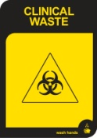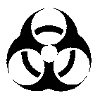
 |  | Sharps | Thick Yellow Container | Needle stick proof containers. Clearly marked as sharps containers | Needle proof Gloves | 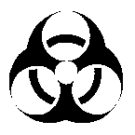Sharps
 |  | Anatomical Waste | Burgundy Bin | Biohazard symbol and the words ‘clinical waste’ and/or ‘anatomical waste’ are to be displayed on the container | Gloves/Apron/mask
 |  | Cytotoxic Waste | Purple Bin | Purple container or MGB marked with the cell in telophase symbol in white | Gloves/Apron/Mask | 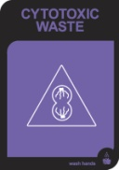
 |  | Pharmaceutical Waste |  | Should always be secured and locked | Gloves/mask
2. | General Waste |  |  | Colours may vary (can be all black or green) | Gloves
 |  |  | Green MGB, Red Lid
3. | Recyclables – Main Streams | Paper - Non secure |  | Bin commonly blue with white lid. | Gloves | Reduce Reuse Recycle
 |  |  | Blue MGB, White Lid
 |  | Cardboard |  | Cardboard | Gloves
 |  | Co-mingled |  | Colours may vary (can be red) | Gloves
 |  |  | Green MGB, Yellow Lid
 |  | Paper – Secure | Blue MGB | Bin commonly blue. | Gloves
4. | Radioactive Waste |  | Red Bags / yellow ties | This waste stream is managed by Radiation Oncology Physicists | Gloves/Apron /Goggles/Mask | 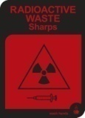
5. | Dangerous Substances |  | Various | Must be handled, stored & transported in accordance with current legislation | Gloves/Apron/Goggles/Mask | 